Lesson 9.2: Translations
Transformation: An operation that moves or changes a geometric figure to produce a new figure, called the image.
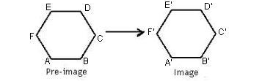
- The original figure is called the pre-image.

Types of Transformations:
- Translations (9.2)
- Reflections (9.1)
- Rotations (9.3)
- Dilations (later)

Translation: Shifting a figure left/right and up/down

Ex1) Triangle ABC has A(0,0), B(0, 4), and C(5, 0). Translate the figure 2 units to the right and 1 unit down. Draw the figure and image and give a general rule for each point on the figure.

If the image is congruent to the preimage, the transformation is an ____________. The transformation preserves distance, angle measure, betweenness of points, and collinnearity.

Ex2) Quadilateral HJLK has H(1, 0), J(0, 4), L( 3, 1), K(2, 5)
If HJLK is translated (x, y) (x +3, y – 5), What are the coordinates of point K’? What are the coordinates of point J’?

Ex3) State the rule for the given translations:
 |  |  |  | A
 |  |  |  |  | B’ |  |  |  | C’
 |  |  |  |  |  |  | C
 | B
A’
a.

H
S
I
F
T
S’
H’
I’
F’
T’

b.

Reflections (Section 9-1)
A reflection is a transformation representing a flip of a figure. Figures may be reflected in a point, a line, or a plane.

Example 1:
a. b.

Some figures can be folded so that the two halves match exactly. A fold is aline of reflection called a line of symmetry. If all the lines of symmetry intersect at the same point, the figure has point symmetry.

Example 2:

Example 3:

Instructions:
For #2-#5, use different colors.
- Write down the coordinates of A, B, C in column 1
- Reflect triangle ABC over x axis. Label the new coordinates: A’, B’ C’ and write them in column 2.
- Reflect triangle ABC over y axis. Label the new coordinates: A’’, B’’, C’’ and write them in column 3.
- Reflect triangle ABC over the line y = x. Label the new coordinates: A’’’, B’’’, C’’’ and write them in column 4.
Original | Reflected over | Reflected over | Reflected over | Reflected over
Coordinates | the x axis | the y axis | the line y=x | the origin
A ( | A’ ( | A’’ ( | A’’’ ( | A’’’’ (
B ( | B’ ( | B’’ ( | B’’’ ( | B’’’’ (
C ( | C’ ( | C’’ ( | C’’’ ( | C’’’’ (
 | Write down | Write down | Write down | Write down
 | observations | observations | observations | observations
 | between points: | between points: | between points: | between points:
 | A & A’ | A & A’’ | A & A’’’ | A & A’’’’
 | B & B’ | B & B’’ | B & B’’’ | B & B’’’’
 | C & C’ | C & C’’ | C & C’’’ | C & C’’’’
- Reflect triangle ABC over the origin. Label the new coordinates: A’’’’, B’’’’, C’’’’ and write them in column 5.

9.3: Rotations
Rotation: A transformation that turns every point of a preimage through a specified angle (angle of rotation) and direction about a fixed point (center of rotation)

Ex1A) Rotate quadrilateral ABCD 60° counterclockwise about point R.

R

Ex1B) Rotate quadrilateral ABCD 40° clockwise about point R.

R

Ex2) Triangle ABC has vertices A(-2, -3), B(-6, -3) and C(-5, -5). Draw the image of ΔABC under a rotation 120° counterclockwise about the origin.

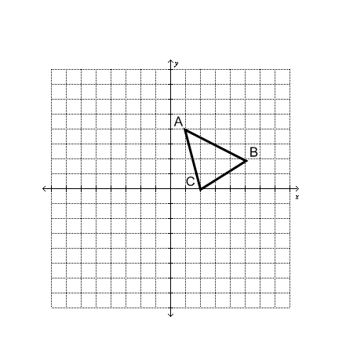
Rotating by a multiple of 90 degrees:
1.
a) Rotate Triangle ABC, 90º counterclockwise.
Label the triangle A′ B′ C′.

b) Rotate Triangle ABC, 180º counterclockwise.
Label the triangle A″ B″ C″.

c) Rotate Triangle ABC, 270º counterclockwise.
Label the triangle A′′′ B′′′ C′′′.

2. Organize your results from #1 in the table.

Starting Point | 90°  Rotation  CC | 180°  Rotation  CC | 270°  Rotation  CC | 360°  Rotation  CC
A (1, 4)
B (5, 2)
C (2, 0)

3. Complete each rule for finding the image of any point (x, y) under the given rotation.

a) 90° rotation about the origin: (x, y) → ( , )

b) 180° rotation about the origin: (x, y) → ( , )

c) 270° rotation about the origin: (x, y) → ( , )

d) 360° rotation about the origin: (x, y) → ( , )

4. What are the coordinates of (3, - 2) under a 90° counterclockwise rotation about the origin?

5. What are the coordinates of (- 5, 4) under a 180° counterclockwise rotation about the origin?

6. What are the coordinates of ( 3, 2) under a 90° clockwise rotation about the origin?

