Notes: Chapter 2.2 Day #1 Normal Distributions
What is a Normal Distribution?
- Last class, we briefly looked at density curves
- Once special type of density curve is the ______________.
- These density curves are symmetric, single peaked, and bell shaped. Normal curves describe Normal distributions.
  - All Normal distributions, although they may vary in appearance somewhat, have the same overall shape.
- We describe a Normal distribution by giving its _________ and its ______________________.
- Because Normal distributions are symmetric, the mean is located in the _______ of the distribution and is _______ to the median.
Changing the Mean and Standard Deviation:
- Changing μ without changing σ:

- Changing σ without changing μ:

Inflection Points:
- The points at which the change in the Normal distributions curvature take place (where is goes from a steep decline to a less steep decline) are called the inflection points.
- Sketch:

- Why are these points useful?

- WARNING!:

Why the Normal Distribution?
(1)

(2)

(3)

WARNING: Although many sets of data follow a Normal distribution, there are also many that do not.
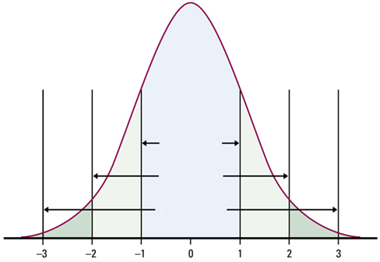

The 68-95-99.7 Rule (AKA the Empirical Rule)
- Approximately _____ of the observations
fall within σ of μ.

- Approximately _____ of the observations
fall within 2σ of μ.

- Approximately _____ of the observations
fall within 3σ of μ.

Using the Empirical Rule:

- Heights of young women, μ = 64.5 inches and σ =2.5 inches.
- Ex1) Between what heights do 95% of women fall?

- Ex2) There are 100 women in a room. What # of women would we expect to have heights within 1 standard deviation of the mean?

- Ex3) There are 11 women in this room. What # would we expect to have heights greater than 67?

Notation:
Because Normal distributions come up a lot in statistics, we abbreviate a Normal distribution with a mean μ and a standard deviation σ as
N(μ ,σ)
For example, the distribution of young women’s heights would be _______________.

