Lesson 6.1: Simulation

The Idea of probability:
- Chance behavior is unpredictable in the short run, but has a regular and predictable pattern in the long run.

- The law of large numbers says that if we observe more and more repetitions of any chance process, the proportion of times that a specific outcome occurs approaches a single value.

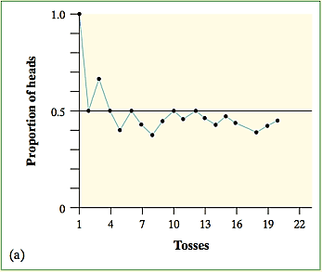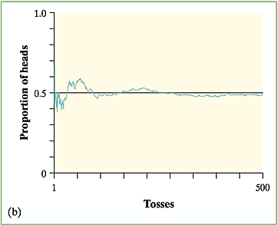

- The probability of any outcome of a chance process is a number between 0 and 1 that describes the proportion of times the outcome would occur in a very long series of repetitions.

Probability Myths:
- The myth of short-run regularity:
  - The idea of probability is that randomness is predictable in the long run. Our intuition tries to tell us random phenomena should also be predictable in the short run. However, probability does not allow us to make short-run predictions.

- The myth of the “law of averages”:
  - Probability tells us random behavior evens out in the long run. Future outcomes are not affected by past behavior. That is, past outcomes do not influence the likelihood of individual outcomes occurring in the future.

Simulations can help us to determine probabilities (fairly accurately if we use a large number of trials!)

Simulation Steps:
- Step 1: Clearly describe how you will assign digits to represent outcomes
- Step 2: State independence and/or non-replacement
- Step 3: Define trial/count
- Step 4: Simulate many repetitions. (Use table)
- Step 5: State your conclusion

EXAMPLE 1: Toss a coin 10 times. What is the likelihood of a run of at least 3 consecutive heads or 3 consecutive tails?

Step 1: Assign digits to represent outcomes.
- One digit simulates one toss of the coin.

- Odd digits represent heads; even digits represent tails.

Step 2: State independence and/or non-replacement
- Each coin flip is independent of previous coin flips.

Step 3: Define trial/count
- To complete one trial, I will read groups of 10 digits to represent 10 coin flips and note if there was a run of at least 3 consecutive heads/tails

Step 4: Simulate many repetitions. (Use table)

Let’s do the first three repetitions.
Digits: | 1 9 2 2 3 | 9 5 0 3 4 | 0 5 7 5 6 | 2 8 7 1 3 | 9 6 4 0 9 | 1 2 5 3 1

Let’s say that twenty-two additional repetitions were done for a total of 25 repetitions…23 of them did have a run of 3 or more heads or tails.

Step 5: State your conclusion. We estimate the probability of a run of size 3 is:

Example #2: Frozen Yogurt Sales

Orders of frozen yogurt flavors (based on sales) have the following relative frequencies: 38% chocolate, 42% vanilla, and 20% strawberry. How many customers would we expect to order before 3 people order strawberry?

Step 1: Clearly describe how you will assign digits to represent outcomes

Step 2: State independence and/or non-replacement

Step 3: Define trial/count

Step 4: Simulate many repetitions. (Use table)

3 8 4 4 8 4 8 7 8 9 1 8 3 3 8 2 4 6 9 7 3 9 3 6 4 4 2 0 0 6
7 6 6 8 8 0 9 8 3 4 8 5 4 6 8 1 6 8 5 4 5 3 3 9 6 3 8 1 5 4
1 2 1 9 3 6 5 3 6 0 0 9 2 4 1 7 8 6 8 2 4 9 4 3 6 1 7 9 0 9
0 6 5 6 8 7 9 6 4 1 8 8 8 3 1 4 8 9 3 0 0 8 1 6 7 6 4 7 5 1
1 2 0 8 0 7 5 7 8 9 0 8 2 7 3 9 6 8 4 1 7 3 5 0

Step 5: State your conclusion

