ANSWERS
- $A'$ $B'$ ($A∩B)'$
$(A∪B)'$ $A'∩B$ U 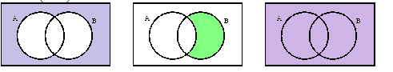
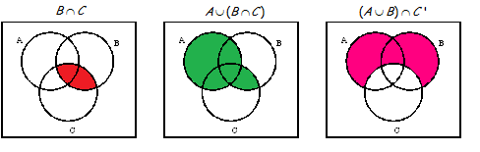
- a) n(U) = 9
b) n( $A∩B$) = 4
c) n( $A∪B$) = 7
d) n($A'$) = 3
- a. 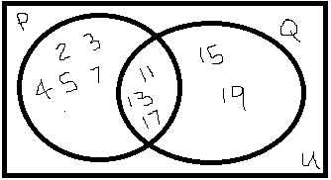
b. $P∩Q=11, 13, 17$ ii. $P∪Q^{'}=2, 3, 4, 5, 7$
4. a. Q = {2, 4, 6, 7, 10, 12, 14, 16, 18, 20, 22, 24, 26, 28}
b. R = {1,3,5,7,9,11,13,15,17,19,21}
c. S = {3,5,7,11,13,17,19}
d. T = {4, 9, 16, 25}
e. U = {8, 27}
5. State whether each of the following statements is true or false.
  - T
  - T
  - F
  - F
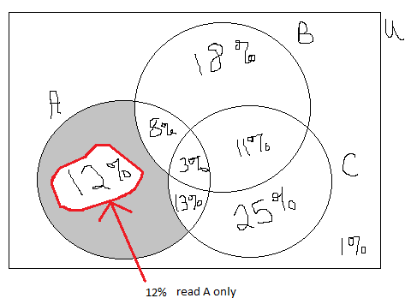
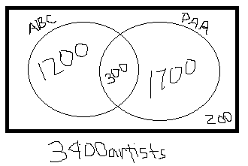
6. 8.

9.
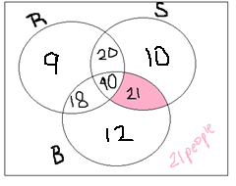
Work for 9: 