Geometry: Segment Addition and Distance Name___________________

Draw a picture and then write the Segment Addition Postulate for the points described.
1. S is between D and P 2. J is between S and H

C is between A and E. For each problem, draw a picture representing the three points and the
information given. Solve for indicated segement.
2. If AC = 24 in. and CE = 13 in., AE = _____. 3. If CE = 7in. and AE = 23 in., AC = _____.

Refer to the figure and the given information to find each measure.

4. Given : AC = 39 m
C
.
A
B

2x-8
x+17

x = ________
AB = _______
BC = _______
5. Given the figure and DG = (2x + 38) ft
D
O
G
4x- 3
2x + 21

x = _______
DO = ______
OG = ______

If U is between T and B, find the value of x and the lengths of the segments. (Hint: Draw a
picture for each problem with the given information and then write the equation to solve.)
6. TU = 2x, UB = 3x + 1, TB = 21 7. TU = 4x-1, UB = 2x -1, TB = 5x
x = _______
TU = ______
UB = ______
x = _______
TU = ______
UB = ______
TB = _______

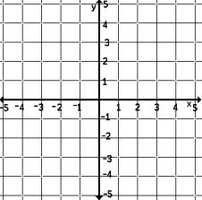
8. Find the distance between the following points:
a. A(-1, 2), B(2, -4) use Pythagorean theorem

b. C(11, -12), D(6, 2) use distance formula

c. E(-10, 0), F(-7, 6) use either method.

9. Which of the segments in question 8 were congruent? ____$≅$ ____

