**Lesson 3.2: Line of Best Fit**

* A **line of best fit** is a line that is drawn on a scatterplot so that approximately as many points lie above the line as below it.
* To draw a line of best fit by hand:
  + Find the **mean** of each set of data and plot this point.
  + 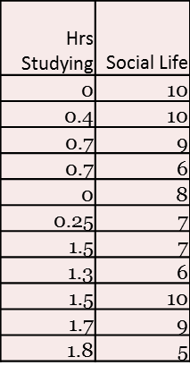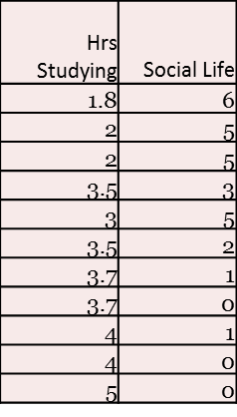Draw a line that passes through the mean and best represents the data.

$\overline{x}=___________$ and $\overline{y}=___________$

( , )

The Least Squares Regression Line

* Line that makes the sum of the squared **vertical distances** of the data points from the line **as small as possible**. **GOES THROUGH THE MEAN.**

Equation of the LSRL:

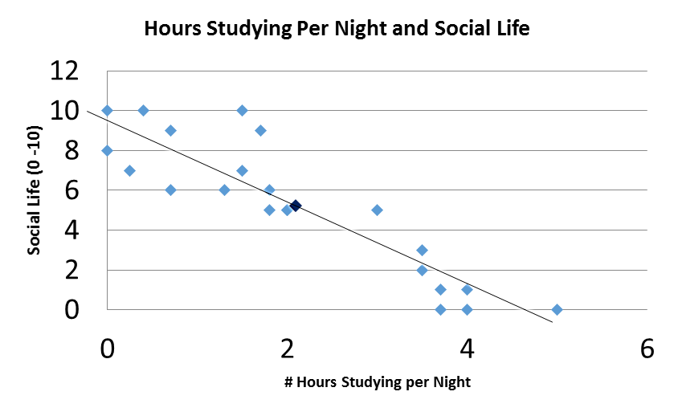

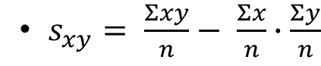

Using your calculator to find the LSRL:

Interpreting the LRSL:

* Interpret the y-intercept IN CONTEXT:
* Interpret the slope IN CONTEXT:

Careful:

* A small slope does not mean an insignificant relationship and a large slope does not necessarily signify importance!!!

Making Predictions:

* + What social life score would you predict for a student studying 3 hours per night?
  + If a person has a social life score of 6, how many hours would you predict that they study each night?
  + If a person spends 12 hours studying per night, what would you predict their social life score to be?

What is r2? ….I am so glad you asked!!!

* 🡨 It is literally r (correlation coefficient) squared.
* It tells us: The percentage of the variation in the values of y that can be explained by the variation of x.
* In our Studying vs. Social Life example: