Reflections (Section 9-1)
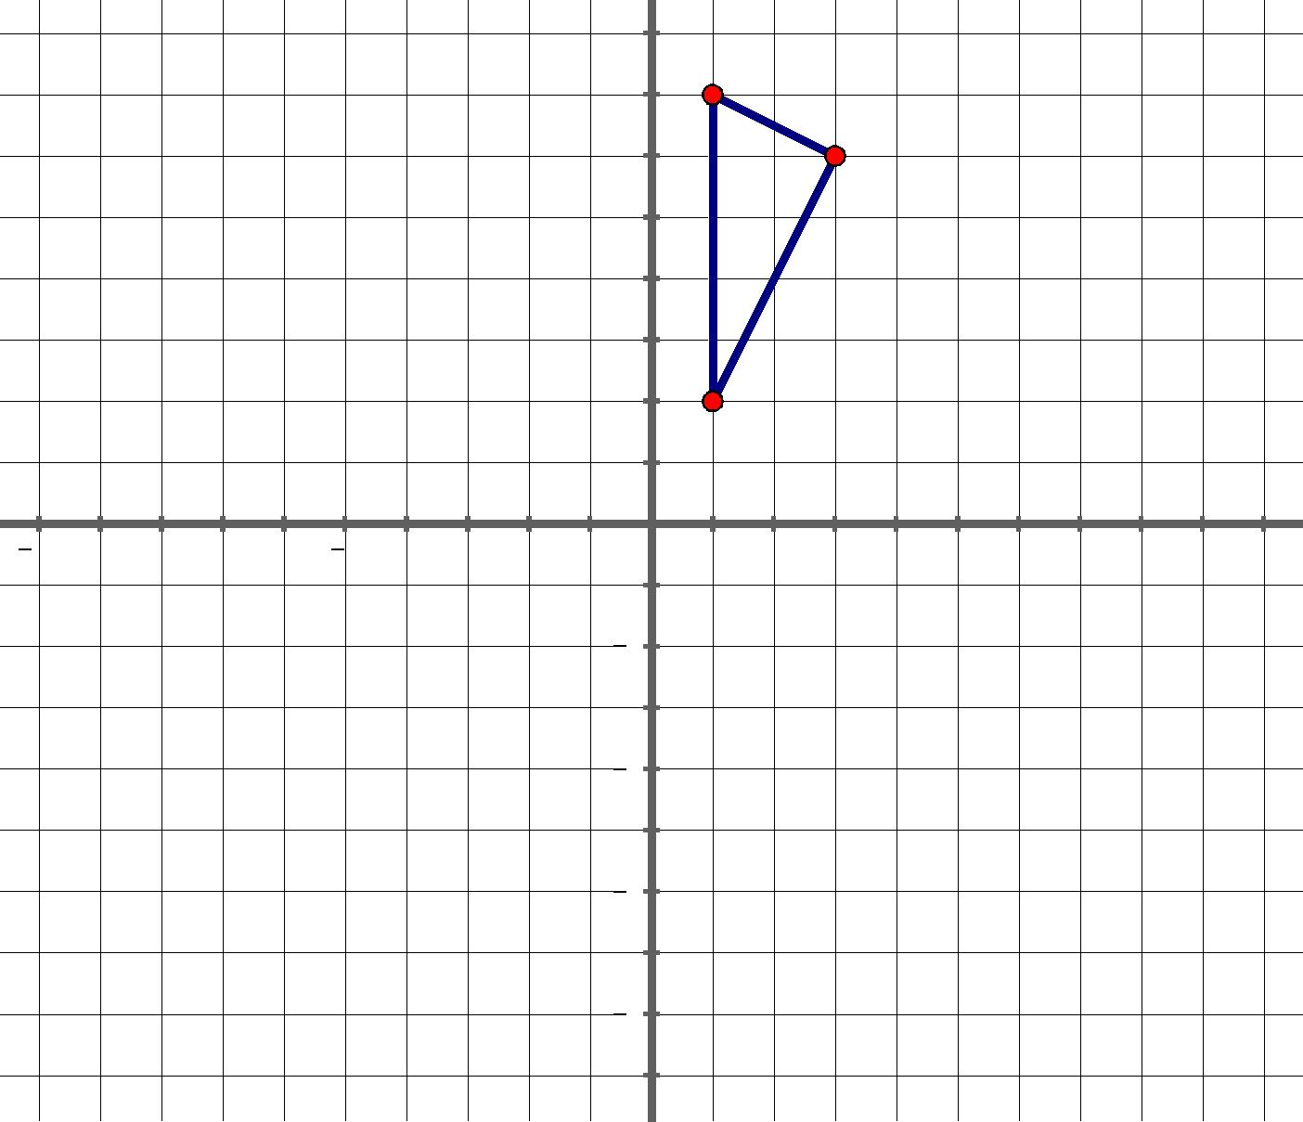
8
 | A
6 | B
4
2
 | C

10 | 5 | 5 | 10

2

4

6

8

Instructions:
Use the table on the next page. For #2-#5, use different colors.

- Write down the coordinates of A, B, C in column 1
- Reflect triangle ABC over x axis. Label the new coordinates: A’, B’ C’. Write down the coordinates in column 2.
- Reflect triangle ABC over y axis. Label the new coordinates: A’’, B’’, C’’. Write down the coordinates in column 3.
- Reflect triangle ABC over the line y-x. Label the new coordinates: A’’’, B’’’, C’’’. Write down the coordinates in column 4.
- Reflect triangle ABC over the origin. Label the new coordinates: A’’’’, B’’’’, C’’’’. Write down the coordinates in column 5.

Original | Reflected over | Reflected over | Reflected over | Reflected over
Coordinates | the x axis | the y axis | the line y=x | the origin
A ( | A’ ( | A’’ ( | A’’’ ( | A’’’’ (
B ( | B’ ( | B’’ ( | B’’’ ( | B’’’’ (
C ( | C’ ( | C’’ ( | C’’’ ( | C’’’’ (
 | Write down | Write down | Write down | Write down
 | observations | observations | observations | observations
 | between points: | between points: | between points: | between points:
 | A & A’ | A & A’’ | A & A’’’ | A & A’’’’
 | B & B’ | B & B’’ | B & B’’’ | B & B’’’’
 | C & C’ | C & C’’ | C & C’’’ | C & C’’’’

Properties for Reflection

 | Property | True of False
a. | Distance is preserved. In other words, lines are taken to lines, and
 | line segments to line segments of the same length.
b. | Orientation is preserved. In other words, order of points is
 | preserved.
c. | Angle measure is preserved. In other words, angles are taken to
 | angles of the same measure.
d. | Collinearity is preserved. In other words, if three points lie on the
 | same line, then their images lie on the same line.
e. | Betweeness is preserved. In other words, if B is between A and C
 | on a line, then B’ is between A’ and C’ on the image.

