Radical Math

Credit Cards 101:
Teaching Young People the
Truth about the Plastic Peril

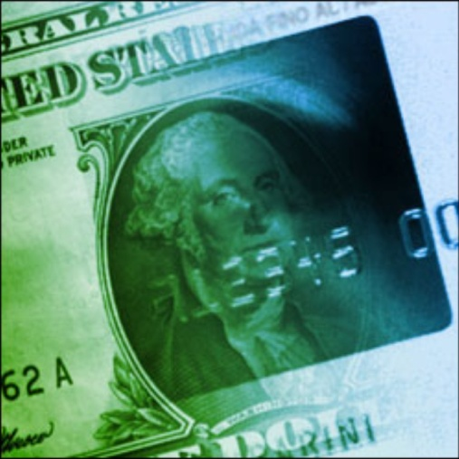
Miss Rose
Algebra 1B

Modified from © Jonathan Osler, 2006 (Working Draft)

Credit Cards 101 Unit Packet Due:___________ Name: ____________________
Day #1: Introduction
- Financial Literacy Survey ___
- Class Activity
- Homework: None
Day #2: Credit Cards and Debt
- Notes ___
- Classwork: “How Much Will they Pay?” ___
- Homework: Read “No Money, Mo Problems” and “Credit cards Aim Marketing at Young Customers” and answer questions. ___
Day #3: Credit Card Terminology
- Notes ___
- Classwork: Paying off debt ___
- Homework: The Privilege of Owning Before Paying ___

Day #4: Credit Card Terms
- Credit Card Terms Crossword___
- Credit Card Applications ___
- Homework: Understanding a Credit Card Bill ____

Day #5: Comparing Credit Cards
- Comparing 5 offers ___
- Homework: Look through a newspaper, magazine, etc. and bring in an advertisement from some item you might like to buy. This item should cost between $100 and $500. ___

Day #6: What Would it Cost?
- Class Activity: What would it Cost? ___

Day #2 Homework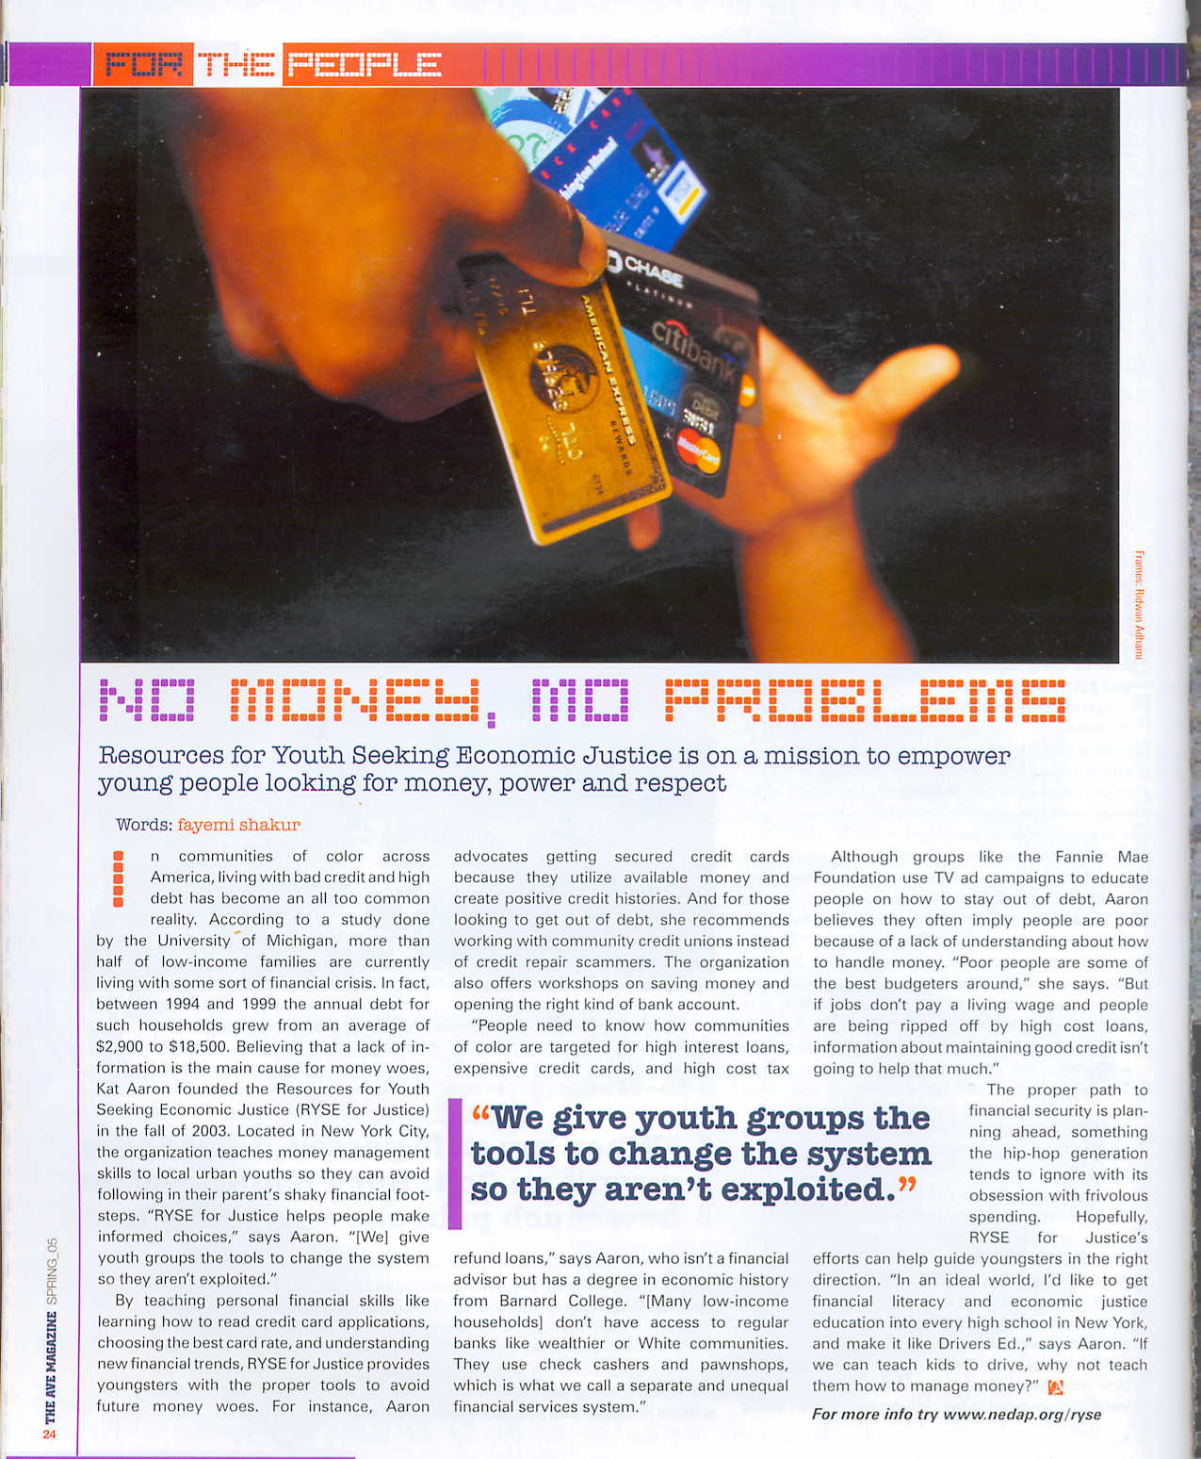

“No Money, Mo Problems”

According to the article, what percent of people of color in the United State are living with some sort of financial crisis?

Kat Aaron, the woman who works for RYSE, suggests that people of color don’t have as much access to banks as white people do and instead get their checks cashed at check-cashers and pawnshops. Why does she refer to this as a “separate and unequal system”?

Aaron also feels that while having good credit is very important, there are other larger issues for poor people and people of color. What does she argue are these other issues?

“CREDIT CARD COMPANIES AIM MARKETING AT YOUNG CUSTOMERS”
By Carol Frey, The News & Observer
Long before Alan Broughton got his high school diploma, he got a Capital One Visa card. Like many of his classmates, Broughton had received two or three credit-card offers before his 18th birthday last October.
"Since I turned 18, I get them all the time," he said.
Parents, consumer advocates and now some members of Congress are expressing alarm at what they see as a take-no-prisoners marketing of credit cards to younger and younger teens.
One prime example is Capital One of Falls Church, Va., among the largest credit-card companies in the world. Capital One began a full-scale sales effort aimed at students 16 to 18 last summer.
And in April, a survey of 2,044 students nationally found that 12 percent of those 12 to 19 have -- and use -- credit cards in their own names.
For teenagers who see gold in that plastic, credit-card debt can become a lead weight that scares away future employers and lenders.
"I interviewed a kid who started college with a $5,000 debt," said Robert Manning, a Georgetown University sociologist who has studied the credit-card market for five years. "We're talking about ruining students' lives forever here."
Credit-card companies say they are after brand loyalty when they market to teenagers, and all but a fraction of teens handle debt as well as any adult. To reduce that fraction, the companies have developed educational programs for parents and schools.
FINDING WAYS TO GET CARDS
Like Broughton, more students are arriving on college campuses with credit cards every year: 15 percent in 1998, compared with 11 percent in 1994, according to Manning.
"The credit-card marketers sign high school kids at college fairs," Manning said. "They get paid by the number of applications they turn in."
Determined students will just keep sending in applications until one gets through, he said.
High school students say they find applications on the Internet, at mall stores offering teddy bears or discounts in return for applying, and in their own mail boxes.
For Jenny Lam, a rising junior, credit-card applications have been easy to come by since she joined a music club at age 14. "I was in a CD club. ... They don't ask you how old you are as long as you pay your bills," she said.

Although she never mailed any of those credit-card applications, Lam said she can readily understand teens who do. "You're 15, and you get something that says you've got a thousand dollars," she said. "You're not telling me you're not going to the store."

ARDER PITCHES IN COLLEGE
When teens get into big trouble with credit-card debt, it's usually at college when they're on their own. And on college campuses of the '90s, they find banks giving away everything from T-shirts to sets of steak knives to students who fill out credit-card applications. Colleges are in cahoots with them, Manning complained.
In a June 8 report for the Consumer Federation of America, Manning relayed the story of a University of Oklahoma freshman named Trisha Johnson who applied for three credit cards during her first semester -- and charged up to her credit limit on all three. After losing her part-time job in December 1997, she committed suicide in her dorm room with her checkbook and $2,500 worth of bills spread out on her bed.
Although suicide is rare, Manning said bankruptcy and dropping out of school to work off credit-card debt are not.
From: www.iccu.com

“Credit Cards Aim Marketing At Young Customers”

According to a recent national survey, what percent of teenagers in the US have a credit card with their own name on it?

What are some sneaky methods that companies will use to reach young people in order to get them to sign up for credit cards?

Day 3 Classwork

Marlon charges $100 to his Visa card with a 12% APR. How much total will he have to pay at the end of the month?

Frank charges $250 to his Mastercard with an 18% APR. How much will he have to pay at the end of the month?

Rosie charges $80 onto her American Express card with an APR of 9%. How much will she owe at the end of the month?

Marjorie has put $500 into a Savings Account that pays her a 2% annual interest. How much will her $500 be worth after one month? How much will her $500 be worth after 2 months?

Day #3 Homework:
The Privilege of Owning Before Paying
José wants to buy a stereo for $650 and pay for it using a credit card that has an Annual Percentage Rate of 19.85%.
If José pays the minimum monthly payment of $21.45:
1. How long will it take him to pay for the stereo?
2. What is the total amount José will pay for the stereo?
3. What is José’s total cost of using credit?
If José makes monthly payments of $60:
4. How many months will it take for José to pay off the stereo?
5. What is the total amount José will pay for the stereo?
6. What is José’s total cost of using credit?
Marie just used her new credit card to buy a bike for $400. Her budget allows her to pay no more than $25 each month on her credit card. Marie has decided not to use the credit card again until the bike is paid off. The credit card she used has an Annual Percentage Rate of 21%.
If Marie pays $25 each month on her credit card:
7. How long will it take Marie to pay for the bike?
8. What is the total amount Marie will end up paying for the bike?
9. How much interest will Marie pay for using her credit card to buy the bike?
If Marie pays the minimum payment of $14 each month:
10. How long will it take Marie to pay for the bike?
11. What is the total amount Marie will end up paying for the bike?
12. How much interest will Marie pay for using her credit card to buy the bike?

Day #4 Classwork: Credit Card Terms

Clues for Credit Card Terms Crossword Puzzle:

Across
3. A rate that can increase or decrease with the changes of the Prime Rate or London Interbank Offer Rate (LIBOR).
4. Usually offered to people with higher incomes and a good credit history. This card has a credit limit above the Platinum level and may include member benefits.
5. Usually offered to people with higher incomes and a good credit history. This card has a minimum credit limit of $5,000 and may include member benefits.
6. The lending rate set by the Federal Reserve to banks. Currently 9.5%
7. The time allowed topay your balance without being charged a finance charge. Usually 25 to 30 days.
9. Allows a cardholder to earn points or money to get cash, merchandise, or services for using the card
11. A low interest rate offered for a limited time, usually for the first 3 to 6 months on being a cardholder. Commonly known as a "Teaser Rate" for persuading cardholders to apply.
12. Different from a credit card as they generally have an annual fee and require the balance to be paid monthly
14. The act of transferring the whole or partial balance of one credit card to another credit card.
16. The yearly percentage rate of the finance charge. The annual percentage rate will be a fixed or variable rate. See "Fixed Rate" or "Variable Rate" for descriptions.
17. A card offered in conjunction with an organization and a credit card issuer. A certain percentage of the finance charges generated from cardholders are donated to the charity or organization featured on the card.
18. A card issued by the cardholder's bank that may be used to make purchases or get cash from ATMs. Each purchase will deduct money from the cardholder's checking account and works much like a check.
19. A card that is secured by a savings account opened with the issuer. The card is designed for people who are looking to rebuild their credit, but are having trouble getting an unsecured card.
21. Another name for the APR
22. A fixed annual percentage rate of the finance charge.
23. The days between the last statement and the current statement.
24. A fee charged by the card issuer for being a card holder. This type of fee is most commonly associated with frequent flyer credit cards or cards designed to help you rebuild your credit.
25. A credit card issued by issuers that may include added benefits not offered with a Classic or Standard credit card. The credit line is generally between $2,000 and $5,000.

Down
1. The Mastercard version of a basic credit card. Generally has a lower credit limit. The Visa version is a Classic Card.
2. An Act passed by Congress in 1975 to help cardholders resolve billing problems with issuers. The Act gave cardholder certain rights when dealing with credit card issuers.
8. The interest rate of a specified period of time.
10. A person who has passed the preliminary screening for the credit card. The person will still need to have their credit checked.
12. Obtaining cash from the card instead of using it to make a purchase.
13. The average account balance for a billing cycle.
15. Miles that can be used for free travel or other discounts, and are earn each time you use your card. Most major U.S. Airlines offer these cards.
20. A credit card that is not secured by collateral. Unsecured cards are the majority of cards issued.
22. The amount of interest charged to an account for the billing cycle.

Understanding a Credit Card Application

Name of Credit Card: ______________________________________________

Annual Fee: _________________ Finance Charge: _________________

Cash-Advance Fees: _________________ Cash-Advance APR: _________________

Grace Period: _________________

Over-Credit Limit Fee: _________________

Annual Percentage Rate (explain below):

Bonus gifts?

Based on the information above, what do you think of this particular Credit Card? Is it a good offer?
Day 4: Homework Understanding a Credit Card Statement
Credit Card Statement Questions
1. What is the date of the statement?
2. What is the Annual Percentage Rate (APR)?
3. What is the corresponding periodic rate?
4. What is the new balance?
5. What was the previous balance?
6. How many charges were made during the billing cycle?
7. How many credits and payments were made during the billing cycle?
8. Were there any charges for late payments? If so, how much were the charges?
9. What is the total amount of the credit line?
10. What is the total amount of available credit?
11. What is the total amount of charges made during the current billing period?
12. Was there a finance charge for the current billing cycle? If so, how much were the charges?
13. What is the account number on the statement?
14. Where should the payment be sent?
15. What is the periodic rate for cash advances?

