Lesson 7-3 Similar Triangles
Two triangles are similar if their angles are the same:
Are these triangles similar?
How many angles do you need to prove similarity?

65°
55°
65°
55°

Similar Triangle Tests:
- AA: Two pairs of angles are congruent.
- SSS: The measures of the corresponding sides of two triangles are proportional.
18 in
F
A
9 in
14 in
D
5 in
E
10 in
C
B
7 in

- SAS: Two sides are proportional and the included angles are congruent.
F
E
D
C
B
A
10 in
14 in
7 in
5 in

A
D
Ex1)
E
- AB|| DC 1)
B
C
2)$∠ABE ≅$ $∠CDE$ 2)
Given: AB|| DC 3)$∠AEB ≅$ $∠DEC$ 3)
Prove: ΔBAE ~ ΔDCE 4) ΔBAE ~ ΔDCE 4)

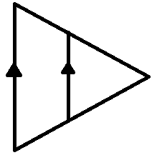
Ex2) Determine whether each pair of triangles is similar. Justify your answer.
- 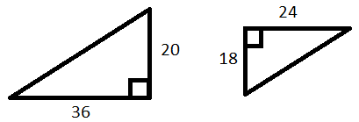 b)

Ex3) Each pair of triangles is similar. Find x and y.
- 

 