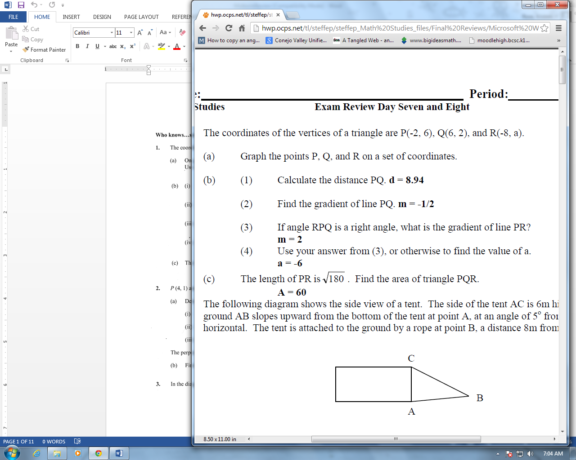

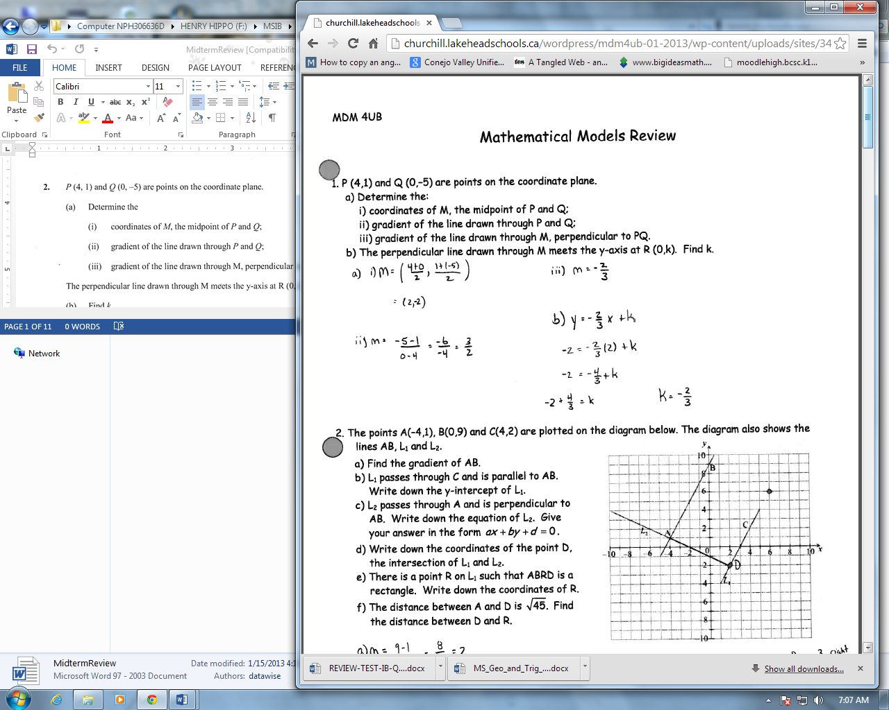

Area path = (10 + 2x)(8 + 2x) - 8*10   
Area path = 80 + 20x + 16x + 4x² - 80   
(a) Area path = 4x² + 36x   
  
4x² + 36x = 208   
4x² + 36x - 208 = 0   
x² + 9x - 52 = 0   
which can be rewritten as   
( x - 4 ) ( x + 13 ) = 0   
now -13 isn't an answer (negative path width) so   
(b) x = 4 m

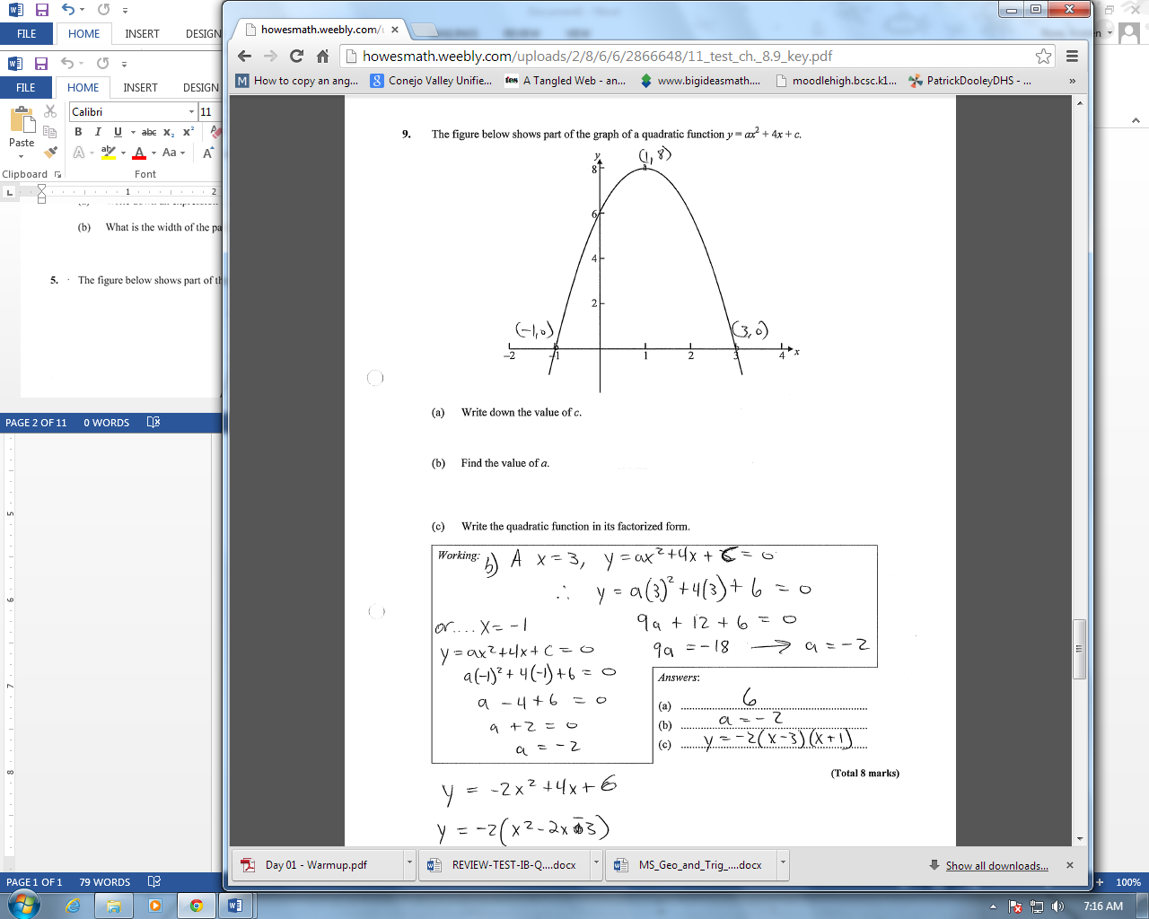

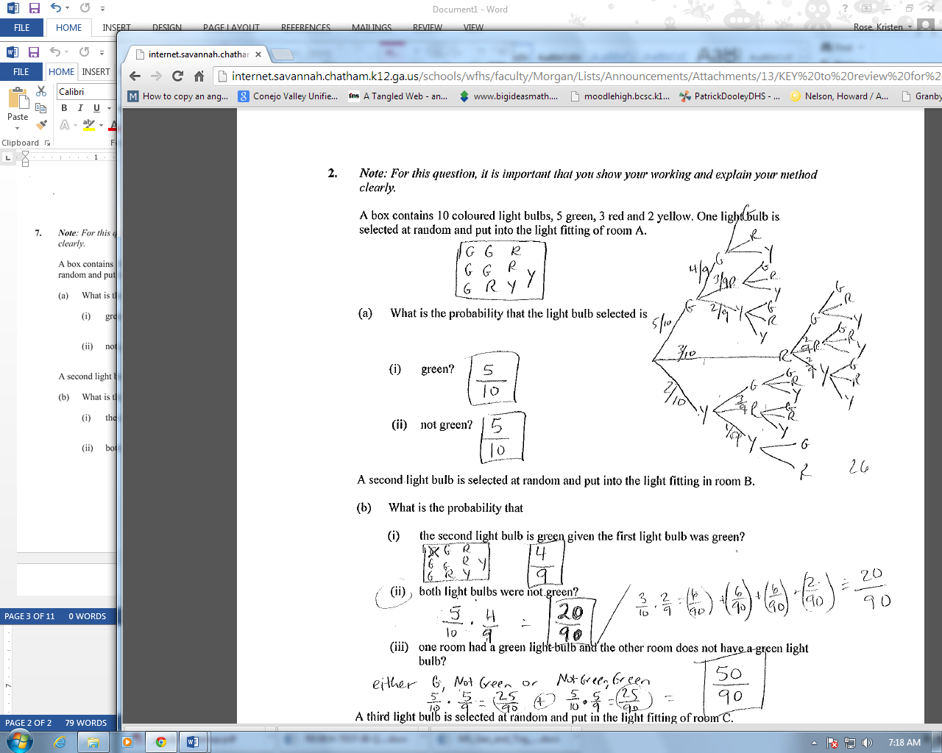

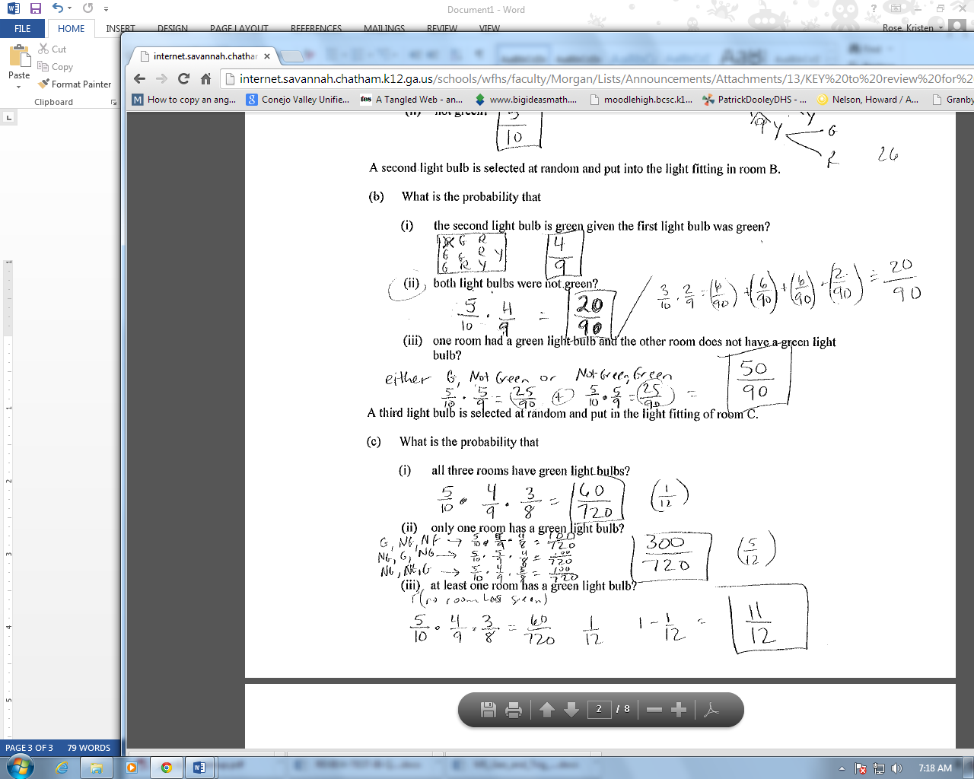

8. a) 0.21, 0.36

b) 276 students

9. (a)___ (b) 2 (c) 71/100 , 27/100, 8/31 (d) 0.002

10. a) For solving for P(*A*  *B*) from the formula in their tables (M1)  
P(*A*  *B*) = 0.2 (A1) (C2)

(b) Because 0.4 × 0.65  0.2 need to see the numbers, not just a statement (R1)  
Therefore no, not independent (A1) (C2)

**Note:** Cannot award (A1) if (R1) not awarded

(c) Because P(*A*  *B*)  0 (R1)  
Not mutually exclusive (A1) (C2)

**Note:** Cannot award (A1) if (R1) not awarded.

[6]

11. (a) (i) 19.2

(ii) 1.45

(b) *r* = 0.942

(c) Strong, positive correlation.

(d) (i) *d* = 11.5 (G1)

(ii) 125 (accept 126)

***Note:*** *Answer must be a whole number*

(e) It is unreliable to extrapolate outside the values given (outlier).

12.

a) (i) Expected number of male managers  
= × 500 =  (M1)(A1)  
= 96 (AG)

(ii) *b* = 160 – 96 = 64 (A1)  
*c* = 300 – 96 – 60 = 144 (A1)  
*d* *=* 240 – 144 = 96 (A1) 5

(b) (i) H0: Position is independent of gender (A1)

(ii) H1: Position is dependent on gender (A1) 2

(c) (i)   
 (M1)(A2)

***Note:*** *Award (M1) for using , (A2) for all values correct.*

*Special case: Award (A1) if only 1 value is incorrect.*

= 12.8 (AG)

(ii) 2 degrees of freedom (A1)  
 = 5.991 (A1)

(iii) Any of: (then reject H0, accept H1) (R1) 6  
Position is dependent on gender.

13. (a)

|  |  |  |  |  |  |  |  |  |  |
| --- | --- | --- | --- | --- | --- | --- | --- | --- | --- |
| *p* | *q* | *p*  *q* | *p*  *q* | ¬*p* | (*p*  *q*)  ¬*p* | ⇒ | *q* |  |  |
| T | T | T | T | **F** | **F** | **T** | T |  |  |
| T | F | F | T | **F** | **F** | **T** | F |  |  |
| F | T | F | T | **T** | **T** | **T** | T |  |  |
| F | F | F | F | **T** | **F** | **T** | F | (A1)(A1)(A1) | 3 |

**Note:** A correct column **always** receives (A1). If a column is incorrect, ft at each subsequent step.  
Whole table does not need to be redrawn, just the 3 columns is enough.

(b) Valid argument or tautology (do not accept “true”) (A1) 1

**Note:** Follow through from candidate’s table as follows: If the implication column is empty award A1 for tautology otherwise ft must be appropriate: invalid or not valid for mixed column or contradiction for four Fs.

14. (a) *“If the water is not cold and not boiling then it is warm”*  
(or equivalent statement) (A2)

(b) *p*  ¬(*q*  *r*) ***or*** *p*  ¬*q*  ¬ *r* (A2)

***Note:*** *Award (A1) for p  and (A1) for ¬(q  r).*

17. a). 70 m

(b) 44.4 degrees

18. (a) PR = 14.83m

(b) 47.05 degrees

(c) h = 6.22m

19. (a) 20 people

(b) 15, 000

(c) 23,000

20. (a)

|  |  |  |  |  |
| --- | --- | --- | --- | --- |
| *L* (cm) | *f* | *f* |  |  |
| 29 | 2 | 2 |  |  |
| 31 | 4 | 6 |  |  |
| 33 | 8 | 14 |  |  |
| 35 | 21 | 35 |  |  |
| 37 | 30 | 65 |  |  |
| 39 | 18 | 83 |  |  |
| 41 | 12 | 95 |  |  |
| 43 | 5 | 100 | (A2) | 2 |

**Notes:** Award (Al) for four correct entries in the column headed f.  
Award (A2) for all 8 correct.

(b)

 (A3) 3

**Notes:** Award (Al) for both axes and correct scale.

(c) (i) Median length of mackerel = 36 cm ± 0.2 cm (M1)  
 = 36 cm (A1)

(ii) Interquartile range of mackerel length = 3.8 ± 0.2 cm (M1)  
 = 4 cm (A1) 4*

*(read from candidate’s curve)

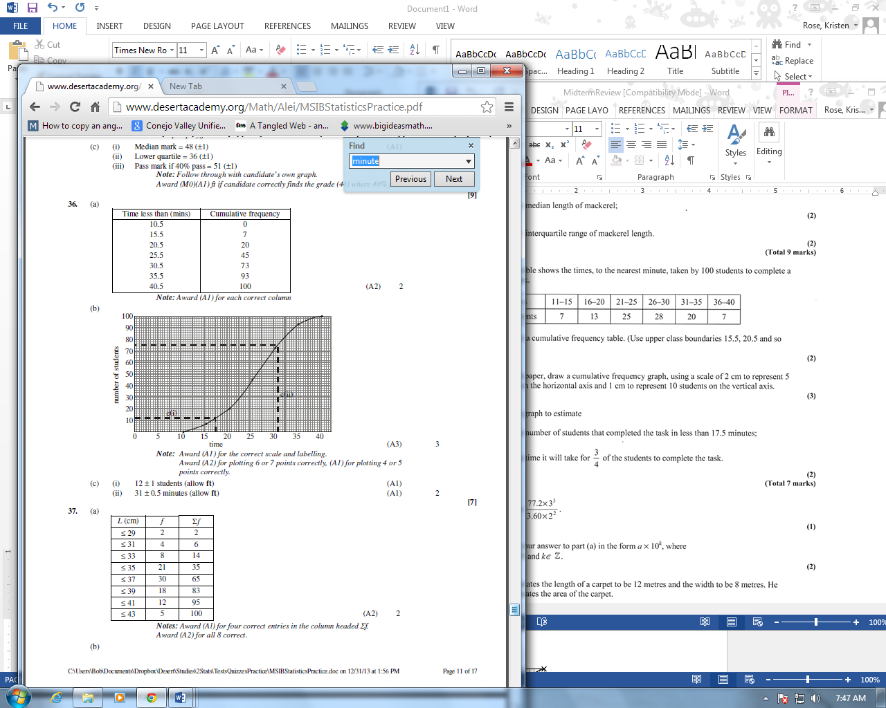

21. (a) 144.75 

(b) 1.4475  102

(c) (i) Area = 96m2

(ii) =  or 6.67%

23. (a) Interval 11–15

(b) Mid-intervals 3, 8, 13, 18 ...

*xf* = 48 + 224 + 338 + ...

Mean = 13

24. 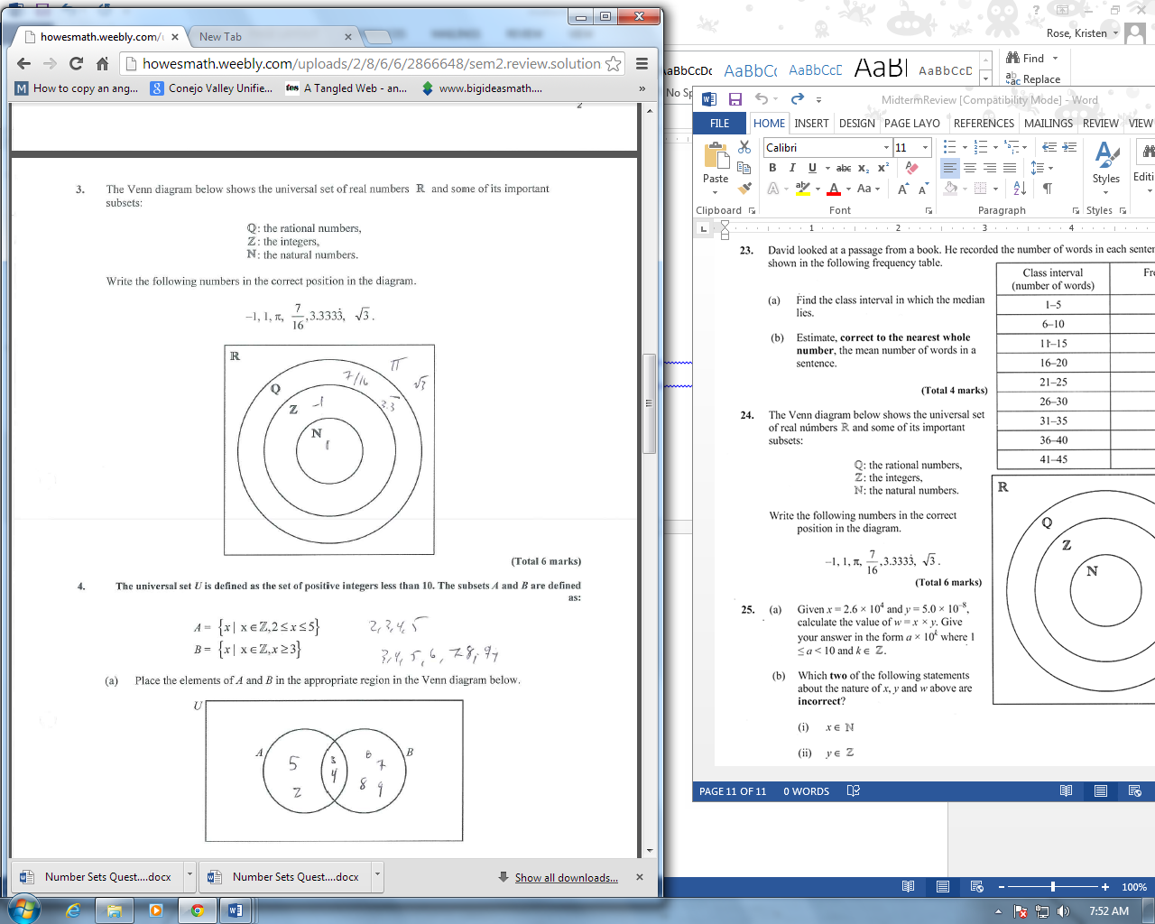

25. a) 1.3 x 10-3

b) ii, iv