Lesson 3.2: Line of Best Fit
- A line of best fit is a line that is drawn on a scatterplot so that approximately as many points lie above the line as below it.
- To draw a line of best fit by hand:
  - Find the mean of each set of data and plot this point.
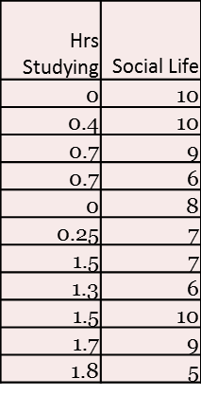
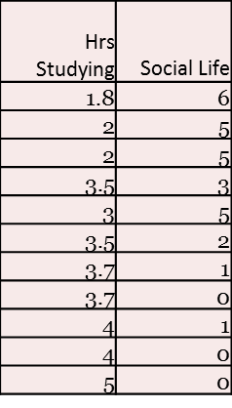
  - Draw a line that passes through the mean and best represents the data.

$\overline{x}=___________$and $\overline{y}=___________$
( , )

The Least Squares Regression Line
- Line that makes the sum of the squared vertical distances of the data points from the line as small as possible. GOES THROUGH THE MEAN.
Equation of the LSRL:

Interpret the slope:

Interpret the y-intercept:

Careful:
- A small slope does not mean an insignificant relationship and a large slope does not necessarily signify importance!!!
Making Predictions:
  - $social life = 9.6 – 2.1\left(hours studying\right)$
  - What social life score would you predict for a student studying 3 hours per night?

  - If a person spends 10 hours studying per night, what would you predict their social life score to be?

  - If a person has a social life score of 6, how many hours would you predict that they study each night?

Using your calculator to find the LSRL:

