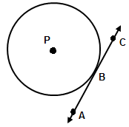
Lesson 10.5: Tangents
- $\overset{⃡}{AC}$ is tangent to circle P because it intersects the circle at only _______ __________.
- This point (point B) is called the:_____________________

Theorem: If a line is tangent to a circle, then it is perpendicular to the radius drawn to the point of tangency.

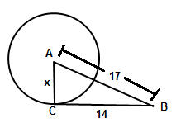
Example 1) $\overline{BC}$ is tangent to circle A at point C. Find x.

Theorem: If a radius is perpendicular to a line on the circle, then that line is a tangent.
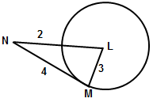
Example 2) Is $\overline{MN}$ tangent to circle L? Justify.

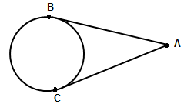
Theorem: Two segments from the same exterior point that are tangent are congruent.

10.8: Equations of Circles
Definition of a circle: The locus of all points in a plane equidistant from a given point.
General equation of a circle:
Where the center is located at ___________ and the radius is ______
Ex 1: (x – 1 )² + ( y – 7)² = 25 Center: _______ Radius: ______
Ex2: (x – 4)² + ( y + 6)² = 25 Center: _______ Radius: ______
Ex3: x ² + y ² = 25 Center: _______ Radius: ______
Ex4: Center (0, 4) radius = 9 Equation: ___________________
Ex 5: Center (-3, 7) radius = $\sqrt{15}$ Equation: ___________________
Ex 6: Center (0, 4) Point on the circle: P(1, 2) Equation: ___________________

Ex 7: Endpoints of the diameter are (-1, 3) and (-5, 7) Equation: ________________

Ex8: What is the exact circumference of the circle with equation (x – 1 )² + ( y – 7)² = 25 ?

Ex9: Find the radius of the circle that has the equation (x – 5)² + ( y – 3)² = r² and passes through the point (5, 1)

Graphing Circles
- Locate the center of the circle
- Use the radius to plot 4 points from the center of the circle
- Connect the dots into something that looks as “circley” as possible
Ex10) Graph (x + 2)² + ( y – 1)² = 9 Ex 11) Graph x² + ( y + 1)² = 16

Ex12) Equation: _________________

Circles Day #2: Equations of Circles + Completing the Square!
Write the equation of the following circles in standard form:
Ex1) x² + 2x + y² = 55 + 10y

Ex2) 8x + 32y + y² = –263 – x²

