3.4: The Sine and Cosine Rules
The sine and cosine rules allow us to find unknown sides and angles in triangles that are not right-angled.
The Sine Rule
- 2 angles and 1 side
- 2 sides and a non-included angle
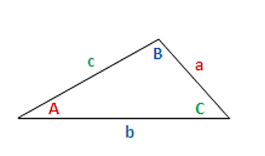
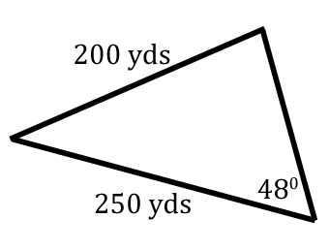
Ex)

Ex) A rectangular block of wood with face ABCD leans against a vertical wall, as shown in the diagram below. AB = 8 cm , BC = 5 cm and angle $B\hat{A}E=28°$.
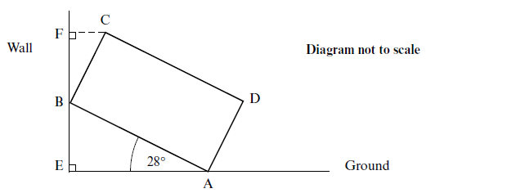
Find the vertical height of C above the ground.

The Cosine Rule
- 3 sides
- 2 sides and an included angle
Ex) Observers on the ground at points A and B, 30 km apart, sight an airplane at angles of elevation of 40° and 76°, respectively. Find the altitude of the plane.

Area of a Triangle:
1. The following diagram shows a triangle ABC.
Calculate the area of triangle ABC.

