1) Go to Khanacademy.org and click “start learning” to make a new account
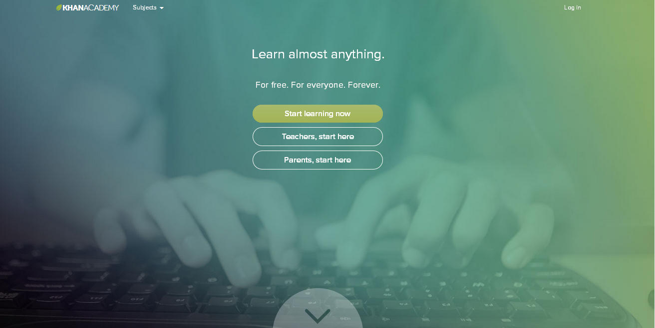
2) Choose to sign up with Facebook, Gmail, or email.
(I DO NOT suggest using Facebook)

3) While you are logged in click on this link: http://khanacademy.org/coaches to go to the page to add a coach

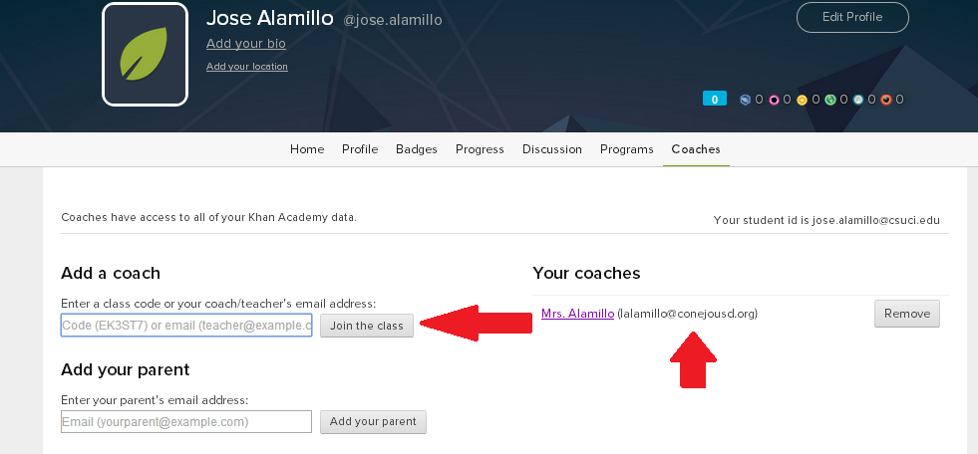
4) Enter the class code (QVB3NH) and click “join the class” If successful then I will show up as your coach

5) Click on your name in the upper right corner and click on “settings”
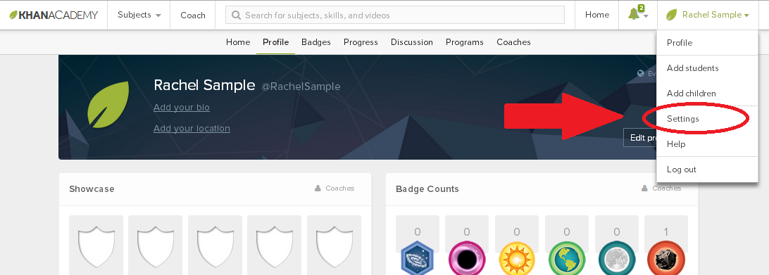

6) Change your “real name” to last name, first name and click “save changes” If this is done correctly then your name should appear last name, first name
