**[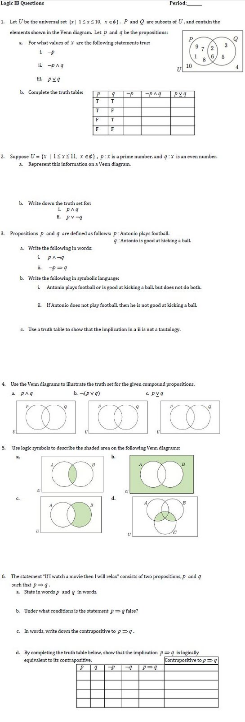](http://1.bp.blogspot.com/-BMIDNcPeSsU/Ta3SPoH4uxI/AAAAAAAAABQ/pzL69oAhR8c/s1600/logic+IB+questions.JPG)**

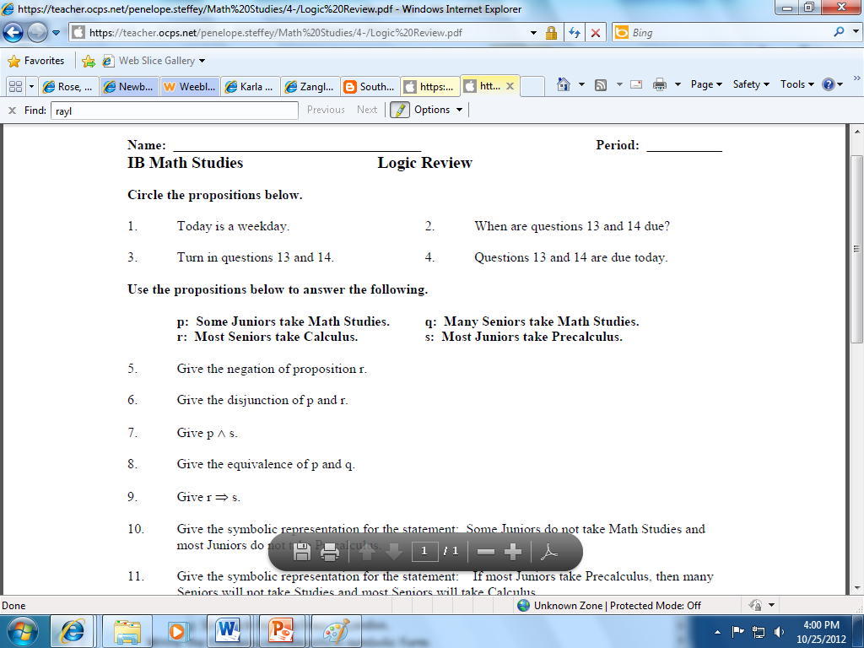



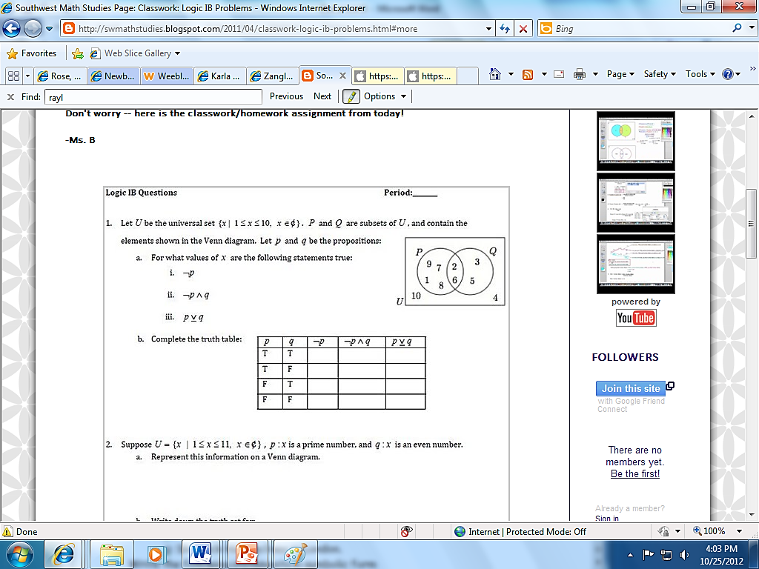

**[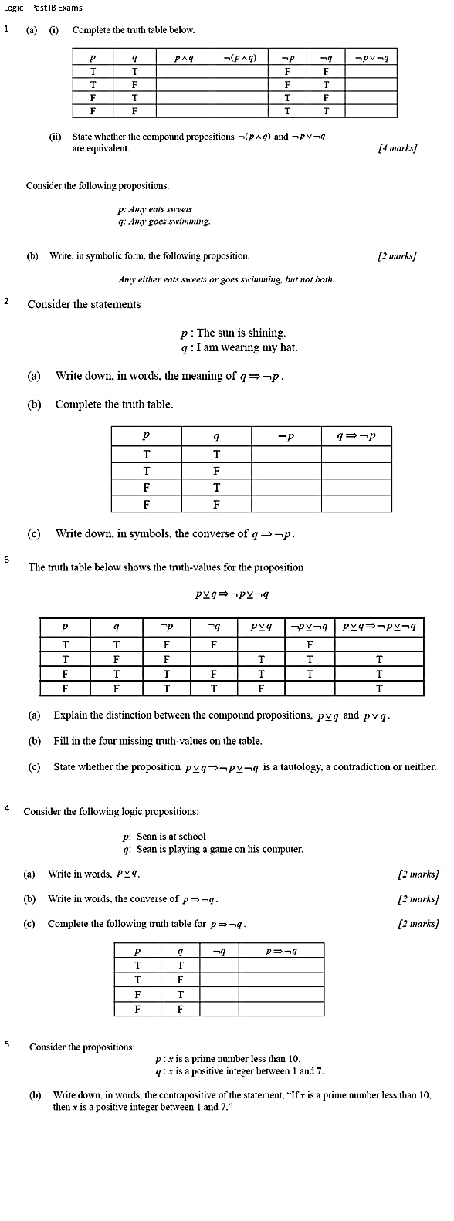](http://2.bp.blogspot.com/-M1KWbsUWsnM/Ta2WZpjAE9I/AAAAAAAAABE/SHz6jvGV3ys/s1600/Extra+Logic+Problems.bmp)**

