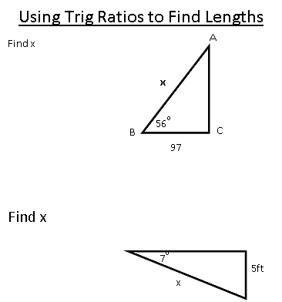 | 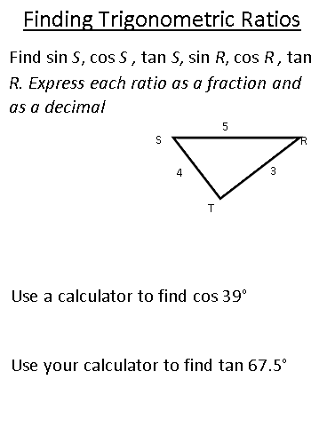
Given Equation To find the angle  SinA = x A = sin⁻¹(x)  CosA = x A = cos⁻¹(x)  TanA = x A = tan⁻¹(x)  x°  3  7  Using Trig Ratios to Find Angles  In order to solve for the angle, we have to use the Inverse function on our calculator. You need to hit the “2nd” button before the trig ratio you want to use.  x°  2  5 | Lesson 8-4: Trigonometry!  Trigonometric Ratios: Sine, Cosine, and Tangent  SOH CAH TOA  sin $(θ)= \frac{ }{ }$  sin ($A)= \frac{ }{ }$  sin ($B)= \frac{ }{ }$  cos $(θ)= \frac{ }{ }$  cos ($A)= \frac{ }{ }$  cos ($B)= \frac{ }{ }$  C  B  A  A  B  C  B  C  A  tan $(θ)= \frac{ }{ }$  tan ($A)= \frac{ }{ }$  tan ($B)= \frac{ }{ }$

