LESSON 1-1: Points Lines and Planes
UNDEFINED TERMS OF GEOMETRY – point, line, plane
- can only be explained by examples/pictures/descriptions
Point: named as point P

Line: Named as line AB or AB; BA

- Collinear: points on the ___________ _____________________.
Plane: named as plane P or Plane XYZ

- Coplanar: points on the ________ _____________________.
Line Segment: A line with two endpoints.

Ray: A line with one endpoint.

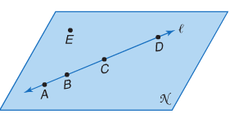
Example 1: Use the figure to name each of the following.
- A line containing point A

- A plane containing point C

- Three points that are coplanar but not collinear.

Example 2: Draw and label a figure for each relationship
- $\overset{⃡}{TU }$lies in a plane Q and contains point R

- Points A, B, and C are coplanar and B and C are collinear.

Points, Lines, and Planes in Space:
Space is a _________________ , __________-dimensional set of ______ _____________.
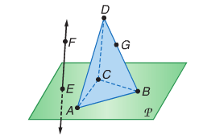
Example 3: Interpret the following drawing:
- How many planes appear in this figure?

- Name three points that are collinear.

- Are points G, A, B, and E coplanar? Explain.

- Name the point where FE intersects plane P.

Example 4: Interpret the following drawing:
a) How many planes appear in this figure?

b) Are points A, B, C, and D coplanar? Explain.

Lesson 1-3: Distance and Midpoints
Finding Distance:
Number Lines
Example 1: Use the number line to find KM
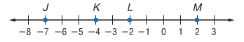

Coordinate Plane
There are two methods for finding the distance between two points on the coordinate plane:
Example 2: Find the distance between R(5, 1) and S(-3, -3)
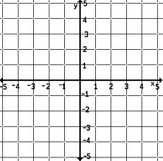
Method 1- Pythagorean Theorem

Method 2 - The Distance Formula 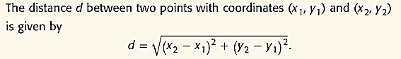

Finding Midpoints:
Midpoint of a Segment: The midpoint of a segment is ________________________
_______________________________________________________________.
M
B
A

If M is the midpoint of $\overline{AB}$, then ______ = _______.

Example 3: Find the measure of BC if B is the midpoint of $\overline{AC}$.
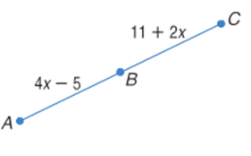

Example 4: Find the midpoint of -3 and 2

Example 5: Midpoint of a Line on the Coordinate Plane
Find the coordinates of M the midpoint of $\overline{JK}$ for J(-1, 2) and K(5, 0)

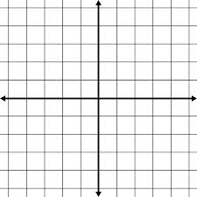

Midpoint Formula: ( , )

You can also find the coordinates of the endpoint if you are given the coordinate of the other endpoint and the midpoint.
Example 7: Find the coordinates of X if Y(-1, 6) is the midpoint of XZ and Z has the coordinates (2, 8)
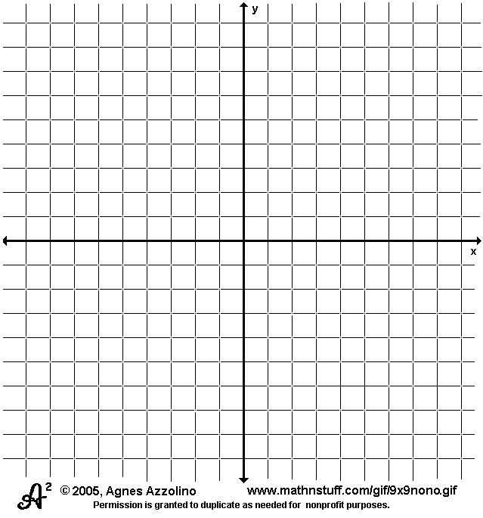
Lesson 1-4: Angle Measure
- An angle is formed by two rays that have a common endpoint. The rays are called the sides of the angle. The common endpoint is the ____________.
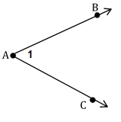

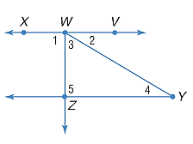
Example 1:
- Name all angles that have W as a vertex.

- Name the sides of $∠$1

- Write another name for $∠$WYZ

To measure an angle you can use a protractor. Angle DBC is a 65 degree (65°) angle.
We say that the degree measure of $∠$DBC is 65 or ___________ = 65
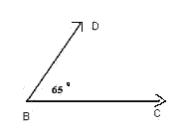

Types of Angles:
Name | Right angle | Acute angle | Obtuse angle
Measure
Model

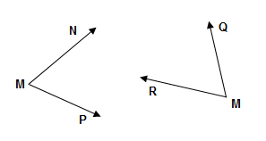
Congruent Angles are angles that have the ___________ ____________________.
$∠$NMP _____ $∠$QMR

Example 2: $∠$NMP≅ $∠$QMR. If m $∠$NMP = 6x + 2 and m$∠$QMR = 8x – 14, find the actual measurements of $∠$NMP and $∠$QMR.

A ray that divides an angle into two _________________ angles is called an ____________ _____________________. (fyi—a line segment can also bisect an angle)
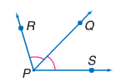
If $\overline{PQ}$ bisects $∠ RPS$, then…

Example 3:$\overline{PQ}$ bisects $∠ RPS$.
a. m$∠RPQ=3x-1 and m∠ QPS=10x-15$. Find m$∠RPQ$.

b. m$∠RPQ=2x and m∠ RPS=20x-4$. Find m$∠RPQ$.

Lesson 1- 5/1.6: Angle Relationship
Angle Pairs….
(1) Adjacent angles are two angles that lie in the ___________ ________, have a
______________ __________ and a ________________ __________, but NO _______________
_________________ points.
Examples: NONexamples:

(2) Vertical Angles are two _____________________ angles formed by two
______________________ lines.
Examples: NONexamples:

- Vertical angles are __________________________.
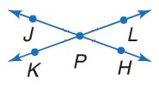
- In the figure:

(3) a linear pair is a pair of _________________ angles with _________________ sides
that are _________________ rays.
Examples: NONexamples:

Example 1: Name an angle pair that satisfies each condition.
- two obtuse vertical angles

- two acute adjacent angles

- a linear pair

Special Angle Relationships:
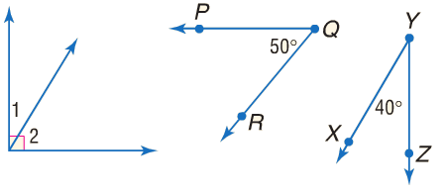
(1) Complementary angles are two angles with measures that have a sum of ______. Remember: It is always _____________ to give a compliment!!!!!

(2) Supplementary angles are two angles with measures that have a sum of ________.
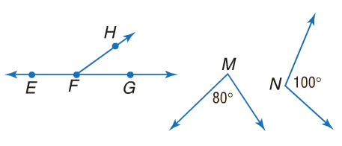

Example 2: Find the measures of two complementary angles if the difference in the measures of the two angles is 12.

Lines, segments, or rays that form __________ __________ are perpendicular.
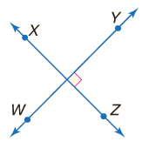
Perpendicular lines…
- intersect to form _______ right angles
- The symbol means “is perpendicular to”

Example 3: Find x and y so that BE and AD are perpendicular.

WARNING: DO NOT ASSUME THAT LINES ARE PERPENDICULAR!!!!!

Example 4: Determine whether each statement can be assumed from the figure at the right.
- $∠$GHM and $∠$MHK are adjacent angles.

- $∠$KHJ and $∠$GHM are complementary.

- $∠$GHK and $∠$JHK are a linear pair.

Lesson 1-6: Two-Dimensional Figures
A polygon is a ____________ figure whose sides are all ___________.
Polygons NOT polygons
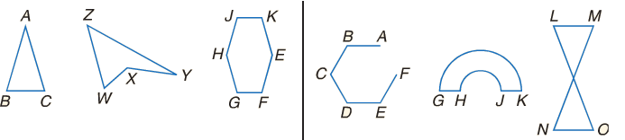
Rules for defining a polygon:
- The sides that have a common endpoint are ________________.
- Each side intersects exactly ______ other sides, but only at their ________________.

Naming a polygon:
A polygon is named by the letters of its vertices, written in order as you go around the figure.

Polygons can be convex or concave. If you draw a line through all the sides of a polygon, if any of the lines pass through the interior of the polygon, then it is concave. Otherwise it’s convex.

You know some polygon names – can you think of any?
In general, we classify polygons by the number of sides they have. A polygon with n sides is an n-gon.
# Sides | Polygon | # Sides | Polygon
3 |  | 8
4 |  | 9
5 |  | 10
6 |  | 11
7 |  | 12

A convex polygon in which all the sides AND angles are congruent is called a regular polygon.

Example 1: Name is each polygon by its number of sides. Then classify it as convex or concave and regular or irregular.
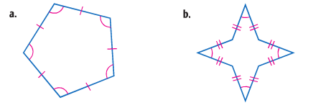

 | Triangle | Square | Rectangle | Circle
Perimeter/ Circumference

Area

Perimeter and Area on the Coordinate Plane
Example 3: Refer to $Δ$PQR with vertices P(-1, 3), Q(-3, -1), and R(4, -1)
- Find the perimeter of $Δ$PQR

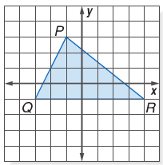

- Find the area of $Δ$PQR

