Lesson 10.1 / Radians and Degrees
Radius: Segment with one endpoint in the
center and one endpoint on the circle.

Chord: Segments with two endpoints on the circle
Diameter: Chord that passes through the center.

Ex1: Name the circle, a radius, a chord, and a diameter of the circle.
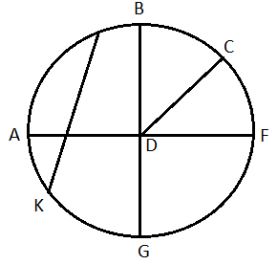
Ex2: The diameters of circles A, B, and C are 10 in, 20in, and 14in respectively. Find XB.
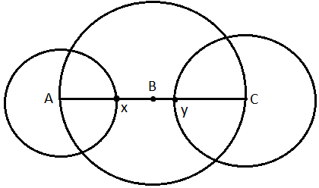

Circumference of a Circle: C = ______ or C = _________
Ex3) a. Find C if r = 10

b. Find d and r to the nearest hundredth if C = 136.9
Ex4) Find the exact circumference of circle P
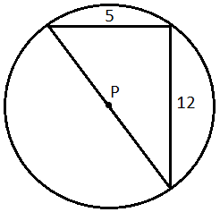

____________________________________________________________________
Radians vs. Degrees

We measure distance using many different units: feet, inches, cm, m, yards, etc.
There are also different units for measuring angles!

We usually use degrees. A circle measure _____ degrees.
We can also use radians. A circle measures ______ radians.

______ degrees = ________radians

______ degrees = ________radians

To convert to radians from degrees, multiply by _________.

Examples: Convert to radians.
5) 1º 6) 23º 7)55º 8) 359º

In order to convert to degrees from radians, multiply by __________.

Examples: Convert to degrees.

1) 3π 2) $\frac{5π}{3}$ 3) - $\frac{π}{5}$ 4) 1.9

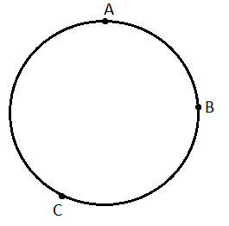
Lesson 10-2: Measuring Angles and Arcs
Minor arc :

Major arc:

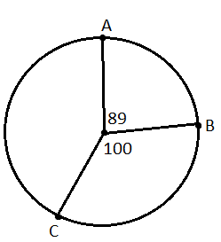
Central angle: vertex at the center, sides contain two radii
Measure of central angle = Measure of intercepted arc.
Find the measures of the arcs:
$\hat{AB}$= $\hat{BAC}$=

Ex1) If the radius is 5, find the length of the arc $\hat{CB}$
- Find the circumference
- Find the fraction of the circle that is the arc.
3. Multiply the fraction times the circumference.

Ex3) If the radius is 6, find the length of each arc
a) $\hat{CB}$ b) $\hat{BAC}$

10.3: Arcs and Chords
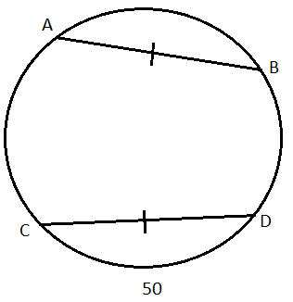
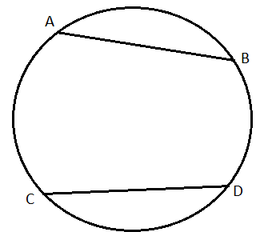
Theorem: Two minor arcs are $≅$ if and only if their corresponding chords are $≅$ Ex1) Find m $\hat{AB}$

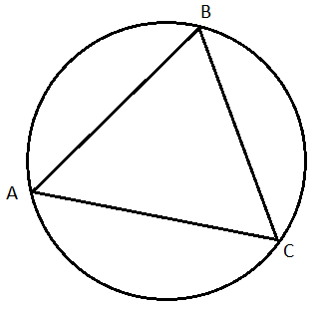

Ex2) $Δ$ABC is equilateral. What is m $\hat{AB}$?

Theorem: If a diameter (or radius) is perpendicular to a chord, then it bisects the chord and its arc.
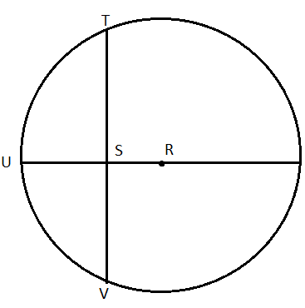
Ex3) $\overline{RS}⊥\overline{TV}$ VS = 10 and m$\hat{TV}$=110°
Find: TS =

TV =

m$\hat{TU}$=

Ex4) Circle R has a radius of 16cm. Radius $\overline{RU}$ is perpendicular to chord $\overline{TV}$, which is 22 cm.
Find RS.

Theorem: Two minor arcs are congruent if and only if they are equidistant from the center.
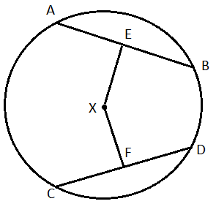

Ex5) $\hat{AB}≅\hat{CD}$ and EX = 7. Find FX.

10.4: Inscribed Angles
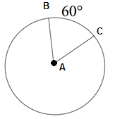  Central Angles: | Inscribed Angles:  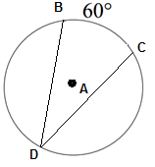

Ex: Find m$DC$ and m$∠ACB$…given m$∠DPC=30$, and mBC = 50
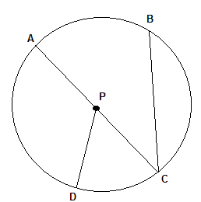
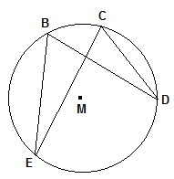
Theorem: If two inscribed angles of a circle (or 2 congruent circles) intercept congruent arcs, then the angles are congruent.
Ex: m$∠BAC=2x+3$
m$∠BDC=x+9$
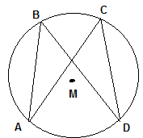

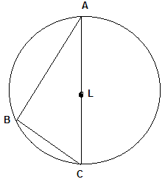
Theorem: If the inscribed angle of a triangle intercepts a semi-circle, the angle is a right angle.
Ex: Find m$∠ABC$

Theorem: If a quadrilateral is inscribed in a circle, then its opposite angles are supplementary.
Ex: Find m$∠ADC$, m$∠BCA$, and mAC
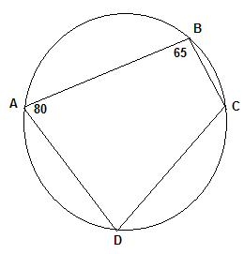

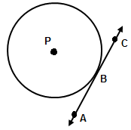
Lesson 10.5: Tangents
- $\overset{⃡}{AC}$ is tangent to circle P because it intersects the circle at only _______ __________.
- This point (point B) is called the:_____________________

Theorem: If a line is tangent to a circle, then it is perpendicular to the radius drawn to the point of tangency.

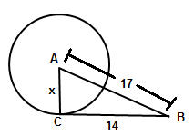
Example 1) $\overline{BC}$ is tangent to circle A at point C. Find x.

Theorem: If a radius is perpendicular to a line on the circle, then that line is a tangent.
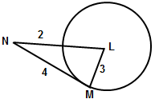
Example 2) Is $\overline{MN}$ tangent to circle L? Justify.

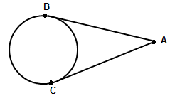
Theorem: Two segments from the same exterior point that are tangent are congruent.

10.8: Equations of Circles
Definition of a circle: The locus of all points in a plane equidistant from a given point.
General equation of a circle:
Where the center is located at ___________ and the radius is ______
Ex 1: (x – 1 )² + ( y – 7)² = 25 Center: _______ Radius: ______
Ex2: (x – 4)² + ( y + 6)² = 17 Center: _______ Radius: ______
Ex3: x ² + y ² = 36 Center: _______ Radius: ______
Ex4: Center (0, 4) radius = 9 Equation: ___________________
Ex 5: Center (-3, 7) radius = $\sqrt{15}$ Equation: ___________________
Ex 6: Center (0, 4) Point on the circle: P(1, 2) Equation: ___________________

Ex 7: Endpoints of the diameter are (-1, 3) and (-5, 7) Equation: ________________

Ex8: What is the exact circumference of the circle with equation (x – 1 )² + ( y – 7)² = 25 ?

Ex9: Find the radius of the circle that has the equation (x – 5)² + ( y – 3)² = r² and passes through the point (5, 1)

Graphing Circles
- Locate the center of the circle
- Use the radius to plot 4 points from the center of the circle
- Connect the dots into something that looks as “circley” as possible
Ex10) Graph (x + 2)² + ( y – 1)² = 9 Ex 11) Graph x² + ( y + 1)² = 16

Ex12) Equation: _________________

Circles Day #2: Equations of Circles + Completing the Square!
Write the equation of the following circles in standard form:
Ex1) x² + 2x + y² = 55 + 10y

Ex2) 8x + 32y + y² = –263 – x²

