Lesson 8-2: The Pythagorean and Its Converse
The Pythagorean Theorem:

Converse of the Pythagorean Theorem:
IF the sum of the squares of measures of the two sides of triangle equals the square of the longest side, then the triangle is a right triangle

A Pythagorean triple is three whole numbers that satisfy the equation ______________.

Ex1) Determine whether each set of measures can be the sides of a right triangle. Then state whether they form a Pythagorean Triple.

- 8, 15, 16 c) $\frac{\sqrt{3}}{5}, \frac{\sqrt{6}}{5}, \frac{3}{5}$

- 20, 48, 52 d) 4$\sqrt{3}$, 4, 8

Chapter 8.3: Special Right Triangles
Use Pythagorean theorem to solve for x. Leave all answers as reduced square roots.

Do you notice a pattern? Write a general rule for 45°–45°–90° triangles in terms of “n”
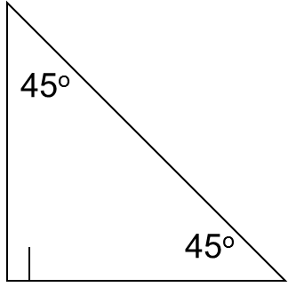
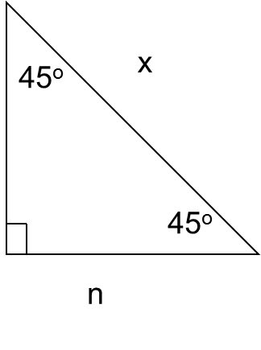
Solve for x. Write all answers in simplified square root form.
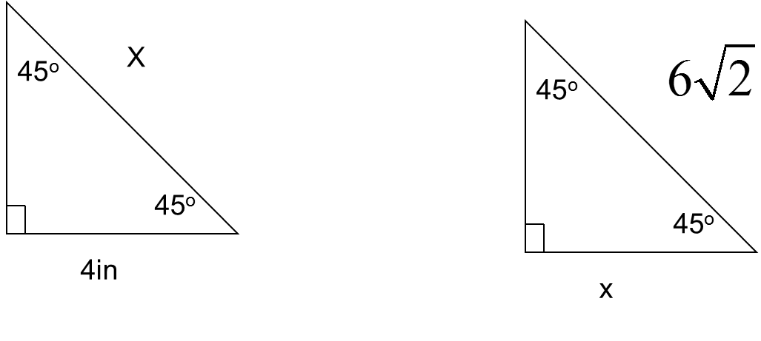

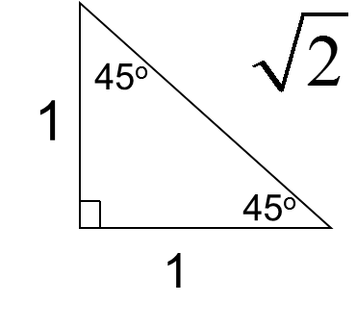
Solve for x. Write all answers in simplified square root form.

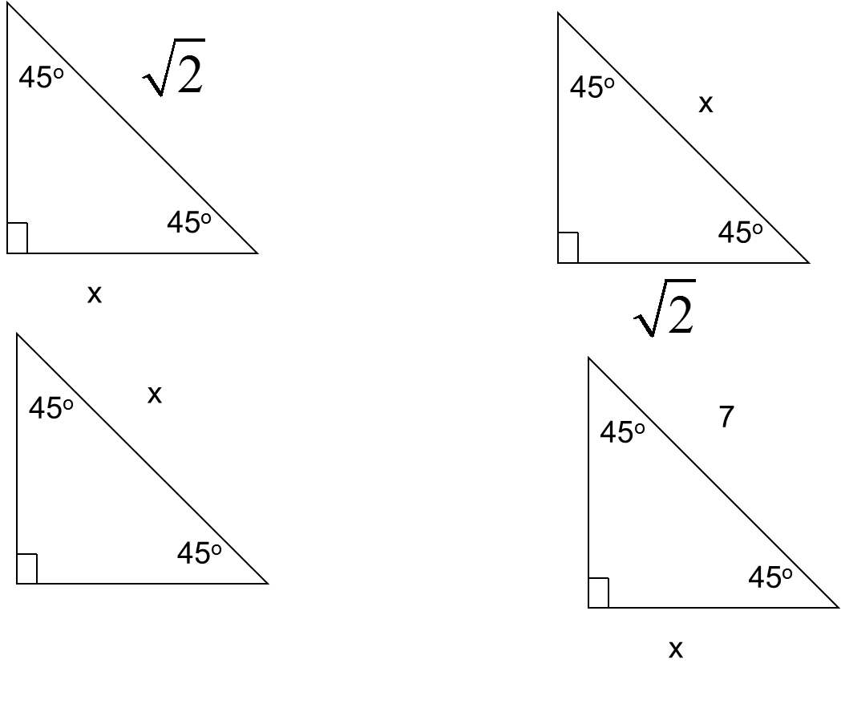
The following are equilateral triangles. Find x and y. Write answers in simplified square root form.
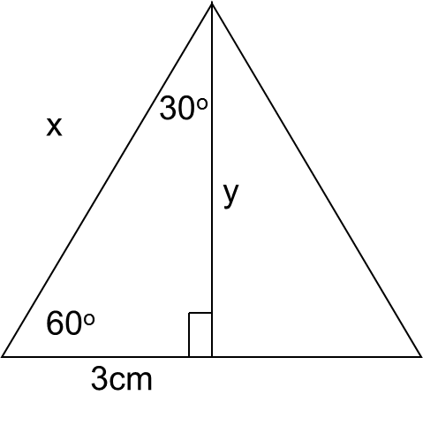
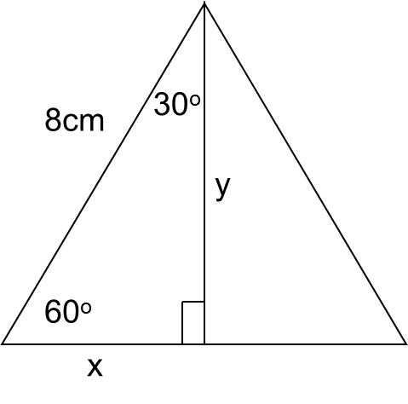

Do you notice a pattern? Write a general rule for 30° – 60° – 90° triangles in terms of “n”
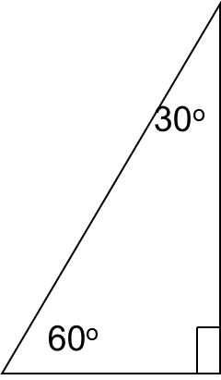
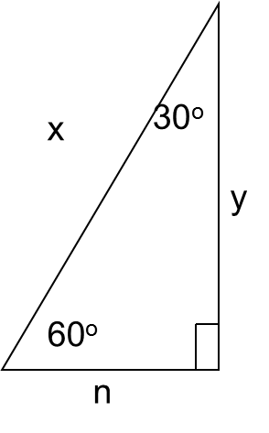

You Try!

Use a calcator to find cos 39°  Use your calculator to find tan 67.5°  Find x  B  C  A  97  x  56°  7°  5ft  x  Using Trig Ratios to Find Lengths  Find x | T  S  R  5  4  3  Finding Trigonometric Ratios  Find sin S, cos S , tan S, sin R, cos R , tan R. Express each ratio as a fraction and as a decimal
Given Equation To find the angle  SinA = x A = sin⁻¹(x)  CosA = x A = cos⁻¹(x)  TanA = x A = tan⁻¹(x)  x°  3  7  Using Trig Ratios to Find Angles  In order to solve for the angle, we have to use the Inverse function on our calculator. You need to hit the “2nd” button before the trig ratio you want to use.  x°  2  5 | Lesson 8-4: Trigonometry!  Trigonometric Ratios: Sine, Cosine, and Tangent  SOH CAH TOA  sin $(θ)= \frac{ }{ }$  sin ($A)= \frac{ }{ }$  sin ($B)= \frac{ }{ }$  cos $(θ)= \frac{ }{ }$  cos ($A)= \frac{ }{ }$  cos ($B)= \frac{ }{ }$  C  B  A  A  B  C  B  C  A  tan $(θ)= \frac{ }{ }$  tan ($A)= \frac{ }{ }$  tan ($B)= \frac{ }{ }$

Lesson 8.5: Angles of Elevation and Depression

An angle of elevation is the acute angle made by the line of sight and the horizontal, when an observer looks up. (hence an angle of elevation).

Ex: The angle of elevation from the ground to the sun is 23°

An angle of depression is the acute angle between the line of sight and the horizontal when an observer looks down (hence and angle of depression)

Ex: The angle of depression from an airplane to the ground is 35°

Angles of elevation and depression are usually at the vertex where the observer is standing, flying, floating, etc.

Because the ground and the horizontal line in the sky are parallel, the angle of depression and angle of elevation are congruent because they are _________ ________ angles.

You should always draw the horizontal line for these problems. (This is easy with angle of elevation because you want to draw the ground, it’s harder to remember with angle of depression!)

Ex1)
- Identify the horizontal and the angle of elevation in this picture.

- Label the angle of depression (you will have to add a horizontal!)

Ex2) Michael, whose eyes are six feet off the ground, is standing 36 feet away from the base of a building, and he looks up at a 50° angle of elevation to a point on the edge of building’s roof. To the nearest foot, how tall is the building?

Ex3) A pilot is traveling at a height of 35,000 feet above level ground. According to her GPS, she is 40 miles away from the airport runway, as measured along the ground. At what angle of depression will she need to look down to spot the runway ahead?

Ex4) Two boars are observed by a parasailer 75 meters above a lake. The angles of depression are 12.5° and 7°. How far apart are the boats?

Lesson 8.6: Law of Sines
What if the triangle is NOT a right triangle?
1) Law of Sines
2) Law of Cosines
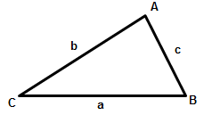
Law of Sines
$\frac{sinA}{a}=\frac{sinB}{b}=\frac{sinC}{c}$

Ex1) Given the measures of $∆ABC$, find the indicated measure. Round angle measures to the nearest degree and side measures to the nearest tenth.
a) If $m∠A=27, m∠B=68,$and $a=3$, find b.

b) if b = 17, c = 14, and $m∠B=92, find m∠C.$

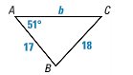
Ex2) Solve $∆ABC$
a)

Ex3) Two radar stations that are 35 miles apart located a plane at the same time. The first station indicated that the position of the plane made an angle of 37 degrees with the lane between the stations. The second station indicated that it made an angle of 54 degrees with the same line. How far is each stations from the plane?

When can you use the Law of Sines?
For any triangle, when you know:
1) AAS or ASA (two angles and one side)
2) SSA (two sides and an angle opposite of one of those sides)

Lesson 8.7: Law of Cosines
Law of Cosines
$a^{2}=b^{2}+c^{2}-2bc\left(cosA\right)$
$b^{2}=a^{2}+c^{2}-2ac\left(cosB\right)$
$c^{2}=a^{2}+b^{2}-2ab(cosC)$
When can you use the Law of Cosines?
For any triangle, when you know:
1) SAS (two sides and an included angle)
2) SSS (three sides)

Ex1) Find a if c = 8, b = 10, and $m∠A=60$

Ex2) Find$m∠R$

Ex3)

Right Triangle | Any Triangle
1) Pythagorean Theorem  *Given 2 sides  2) Special Right Triangles  *30-60-90 or 45-45-90  3) Right Triangle Trigonometry  *given an angle and a side  *given two sides | 1) Law of Sines  *Given a side and an opposite  angle and one other side or  angle.  *AAS, ASA, SSA  2) Law of Cosines  *SSS or SAS

Lesson 9.6: Vectors
A vector is a quantity that has both magnitude (length), and direction, expressed as a directed segment. For example, the speed and direction of an airplane can be represented by a vector.

Symbols:
$$\overset{⃑}{v} or \overset{⃑}{ AB}$$

Component Form:
(1) A vector in standard position has its initial point at (0, 0) and can be represented by the ordered pair for the endpoint.
Ex: The vector to the left could be expressed as…

(2) A vector can also be drawn anywhere in the coordinate plane. In those cases, we express the vectors like this: $〈change in x, change in y〉$ from the end to the starting point.
When we write vectors like this, it is called the component form.
Example 1)
a) Write the component form of $\overset{⃑}{EF}$

b) Write the component form of $\overset{⃑}{BC}$

You can use the distance formula to find the magnitude of a vector. You can describe the direction of a vector by measuring the angle that the vector forms with the x-axis or any other horizontal line.

Example 2) Find the magnitude and direction for $\overset{⃑}{ AB}$

Graph the image of the figure under a translation by the given vector(s).
5)

6)

8)
7)

