Chapter 5.1
- Observational Study vs. Experiment:
- Population:
- Sample:
- Census:
- Sampling:
- The design of a sample refers to the _______ used to choose the ______ from the _________.
  - _________________________ can produce misleading conclusions!
Examples of Poor Sampling Designs:
- Voluntary Response Sample:
  - Ex:

- Convenience Sampling:
  - Ex:
When we use poor sampling methods, they often result in bias. A sampling method is biased when __________________________________________________.
- We can avoid bias by choosing a sample by _________.
Good Sampling Designs:
A ________ ___________ is a sample chosen by chance. These include:
- Simple Random Sample ( ):

  - Ex:

  - Using a table of Random Digits to choose a random sample:
    - (1)
(2)
(3)
(4)

    - Joan’s small accounting firm serves 30 business clients. Joan wants to interview a sample of 5 clients in detail to find ways to improve client satisfaction.
    - Label
      - Be certain that all labels have the ______ number of _____!!!
      - Use the ________ possible labels!
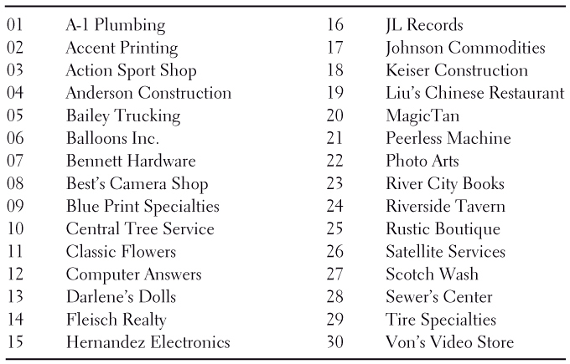
    - Stopping Rule:
    - Table:
69051 64817 87174 09517 84534 06489 87201 97245
    - ID Sample:

(2) Systematic Random Sampling:
Ex:
(3) Stratified Random Sampling:
Ex:
(4) Cluster Sampling:
Ex:
(5) Multistage Sampling:
Ex:

Cautions about Sample Surveys (More sources of bias)
- Undercoverage

- Nonresponse

- Response Bias

- *These problems may or may not cause bias.*
  - Bias will result if the people left out are ____________________________.

Sampling Error/Sampling Variability (it is not the same thing as bias!)
- Sampling Error and Sampling Variability
  - Sampling Variability is a statistical reality. If we selected 50 samples from a population, each one would be somewhat different!
  - Sampling error: Occurs because the sample rarely reflects the population perfectly.
    - Can’t be avoided…we just have to account for it in our calculations (example: margin of error).

