Chapter 3 Practice Test:

For #1-2, refer to the figure below.
- Identify a plane that is parallel to plane ACD
- plane ADH
- plane BAD
- plane EFG
- plane DCG

- Which segment is skew to $\overline{FG}$?
- $\overline{BC}$ C. $\overline{DC}$
- $\overline{GH}$ D. $\overline{CG}$

Refer to the figure below.
For #3 and 4, identify the special name for each angle.
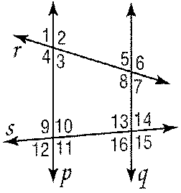
- $∠$3 and $∠$10

- $∠$9 and $∠$13

- Given p$∥$q and m$∠$3 75, find m$∠$5.

- Given p$∥$q and m$∠$10 3x 7 and m$∠$13 4x 9, find x.

- Given ∠1 ∠5, which postulate or theorem justifies that p q?

- If p q by the Consecutive Interior Angles Theorem, which angle pair must be supplementary?

- If m∠4 7x 20 and m∠8 5x 18, find x so that p q.

- Determine the slope of the line that contains the given points.
a. P(6, 3), Q(12, 9) b. X(4, 5), Q(-1, 2)

c. M(8, 14), N(-8, 11) d. A(2, -5), B(8, -5)

- What is the slope of a line parallel to the line containing (6, 6) and (9, 14)?

- Find the slope of a line perpendicular to the line containing (8, 10) and (0, 9).

- Find the equation of the line with slope that contains (4, 7)?

- Find the equation of the line with x-intercept 2 and y-intercept 12?

- Find the equation of the line containing (1, 3) and (7, 15)?

- What is the equation of a line that passes through (1, 5) and is perpendicular to the line y = $-\frac{1}{2}$x + 4

- Find x and y
- 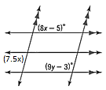

- Find the slope of each line.
  - Find the slope of TU

  - Write the equation of a line perpendicular to TU that passes through (2, 3)

Determine whether and are parallel, perpendicular, or neither. EXPLAIN.
- B(3, 5), T(5, 1), M(2, 6), V(4, 3)

Given the following information, determine which lines, if any, are parallel. State the postulate or theorem that justifies your answer.
- $∠$9$≅∠$16

- $∠$10$≅∠$16

- $∠$12$≅∠$13

- $m∠$12$+ m∠$14 = 180

- If m∠9 110 and m∠8 30, find m∠6.
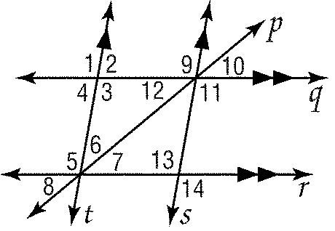

For each proof, use the figure on the above:
25. Given: $m∠16=34, m|\left|n and c\right||d$
Prove: $m∠1=34°$

26. Given: $m∠2=80, , m|\left|n and c\right||d$
Prove: $m∠8=100°$

27. Given:$m∠9=\left(3x-5\right)°, m∠16=\left(8x-40\right)°, , m|\left|n and c\right||d$
Prove: $m∠9=16°$

