Chapter 3.1 Notes: Scatterplots and Correlation

Why do we use scatterplots?
- Used to investigate relationships between _____________ variables.
- Types of Variables
  - Response Variable:
  - Explanatory Variable:

Investigate scatterplots by talking about these 4 things:

Examples:

Form: Form:
Direction: Direction:
Strength: Strength:
Outliers?: Outliers?

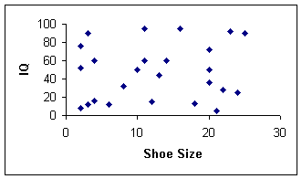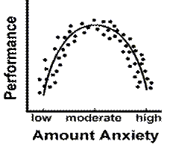
Form: Form:
Direction: Direction:
Strength: Strength:
Outliers?: Outliers?

Correlation Coefficient
- Describes the __________of the ____________ relationship.
- r: Can take all values between -1 and 1 inclusive
  - r =-1
  - r = 0
  - r = +1
  - r = 1.2
- A perfect correlation: all plotted points lie on a straight line.
0 – 0.25 | 0.25 – 0.5 | 0.5 – 0.75 | 0.75 - 1
very weak | weak | moderate | strong

Calculating the Correlation Coefficient (Calculator)

