Chapter 2.2 Standard Normal Distributions
Review:
- Last class we looked at a particular type of density curve called a Normal distribution.
  - All Normal distributions are described by two parameters: ________ and __________
  - Because of this, we can abbreviate a Normal distribution as ____(___, ___)
  - Another important quality of Normal distributions is that the follow the __________ rule. This rule states that ____% of the data falls within 1 standard deviation of the mean, ____% falls within 2 standard deviations and _____% falls within 3 standard deviations.
- All normal distributions are the same if we measure in units of size ___about the _____ __ as center.
  - Changing these units requires that we standardize (like we did in 2.1) using the formula:

  - If the variable we standardize has a normal distribution, then ____________________.
  - The new distribution is called the _________________.

The standard Normal Distribution:
- The standard Normal distribution follows a _________________ and has mean ___ and standard deviation ____
- Notice that the distribution is _________ __________ about 0.
- Remember, the area under a density curve is a proportion of the observations in a distribution.
  - The area under the entire density curve is ____.
  - The proportion of observations to the left of the median is_____.
- We can find the proportion of observation that lie within any range of values simply by finding the ___________________________.
The standard Normal Table:
- Because standardizing Normal distributions makes them all the _______, we can use a single table to find the areas under a Normal distribution.
- This table is called the _______________________________.
  - It’s inside the front cover of you textbook!
  - You will be given this table on the AP exam
- Example: Find the proportion of observations from the standard Normal distribution that are less than -2.15.

- Caution: the area that we found was to the _______ of z = -2.15. In this case, that is what we were looking for.
- HOWEVER if the problem had asked for the area lying to the RIGHT of -2.15. What would that answer be?
  - The total area under the curve is _____.
  - So if 0.0158 lies to the left of -2.15…
  - Then _____ - 0.0158= _______ lies to the ______ of -2.15
- TO HELP YOU NOT MAKE THIS MISTAKE, ALWAYS:
- sketch _________________
- mark the ________
- shade the ________________
- THEN, when you get you answer, ____________________________________!!
Solving Problems Involving Normal Distributions
- Step 1: _______________ in terms of the observed variable x. __________________ of the distribution and ______________________________.
- Step 2: ______________________________. We need to standardize ____ to restate the problem in terms of a standard Normal variable ____. Draw a _________________ to show the area of interest under our now standard Normal curve.
- Step 3: _______________________. Find the _________ under the standard Normal curve using _______________. (careful if the problem asks for the area to the right)
- Step 4: . Write your conclusion in the _________ of the problem.

Example: Cholesterol and Young Boys
- For 14-year-old boys, the mean is μ = 170 milligrams of cholesterol per deciliter of blood (mg/dl) and the standard deviation σ = 30 mg/dl. Levels above 240 mg/dl may require medical attention. What percent of 14-year-old boys have more than 240 mg/dl of cholesterol?

Finding a Value when Given a Proportion
- What if you wanted to know what score you would have to get in order to place among the top 10% of your class on a test?
  - Sometimes, we may be asked to find the observed value with a given proportion of the observations above or below it.
  - To do this, we just read Table A going backwards. In other words, find ______________________________ in the _________of the table, figure out the corresponding _______, and then “______________” to get the __________ value.

- Example: Scores on the SAT Verbal test in recent years ollow approximately the N(505, 110) distribution. How high must a student score in order to place in the top 10% of all students taking the SAT.

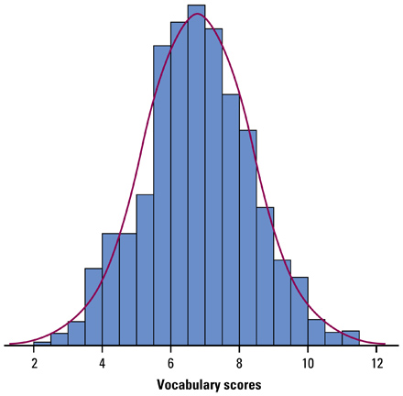
Assessing Normality
Method #1: Graph the data.
Draw a _______________ or _______________ and look for “non-Normal” features of a distributions such as______________, _________, or ________________________________.

Method #2: Use the Empirical Rule.
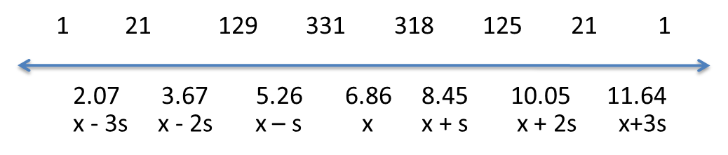

Method #3: Construct a normal probability plot. (calculator)
