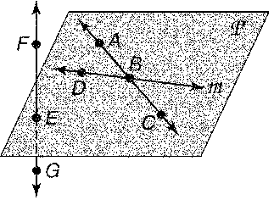
- What is another name of line ?

- Name the intersection of lines and m.

- Name three points coplanar with point A.

Use the figure below for #’s 4-7.

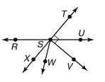
- Name a pair of obtuse vertical angles.

- Name a pair of acute adjacent angles.

- Name a linear pair.

- Name a pair of complementary angles.

- Find the length of BC if B is the midpoint of AC.
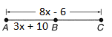

- Find CP if Point P is between C and D, $CP=2x+5, PD=5x-7, and CD=12$

Use the coordinate grid.
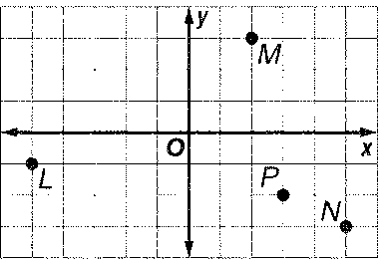

- Find the distance between L and M.

- Find the coordinates of the midpoint of MN.

- Find the coordinates of a point Q if P is the midpoint of NQ.

- Find the dimensions of a rectangle whose length is 3 more than twice its width and has a perimeter of 30 centimeters.

- In the figure, and are opposite rays and bisects ∠WRV.
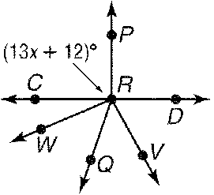
a. Find y if m∠WRQ 48 and m∠QRV 7y 6.

b. Find x if m∠WRQ x and m∠WRV = 7x – 30

c. Find x so that CR ⊥ PR.

- If m∠ABC = 2x, m∠CBF = 3x – 5, and m∠ABF =30. Find m∠ABC.
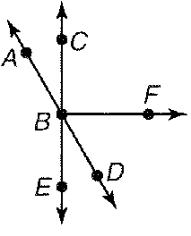

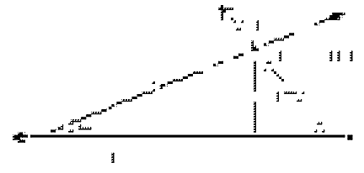
Use the figure below for #’s 16-19
- Find y.

- Find m∠1.

- Find m∠2.

- Find x (hint: the sum of the interior angles of a triangle = 180 degrees!).

- Use polygon ABCDEF
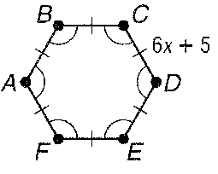
  - Name the polygon by its sides, then classify as convex/concave and regular/irregular.

  - If P = 138cm. Find the length of each side.
21. Find the length of LM if bisects LM at point N, LN 3x 2, and NM = 7x – 1.

