Lesson 13.1: Volume of Prisms/Cylinders
Volume of a Prism:
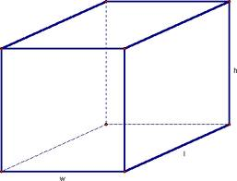
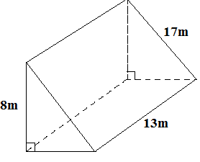
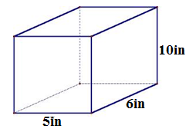
Ex1) Find the volume
a) b)

Volume of a Cylinder:
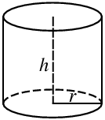

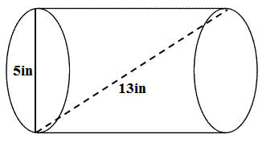
Ex2) Find the Volume

Volume of an Oblique Solid:
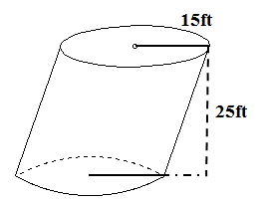
Ex3)

Lesson 13-2: Volume of Pyramids and Cones

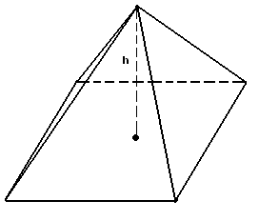
Volume of a Pyramid: Volume of a Cone:
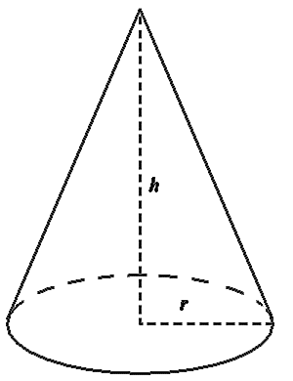

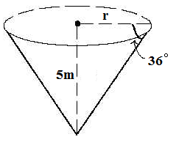
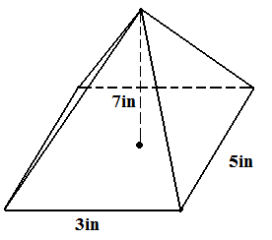
Ex1) Find the Volume Ex2) Find the Volume

Ex3) Find the Volume of the Oblique Cone
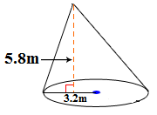
Lesson 13-3: Volume of Spheres

Volume of a Sphere:
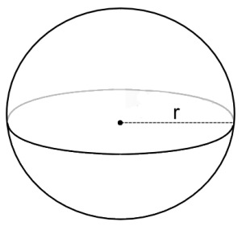

Ex1) Find the volume of the sphere. Round to the nearest tenth.
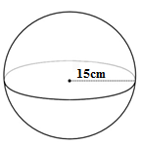
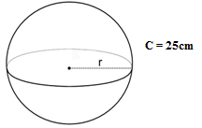
a. b.

Ex2) Find the volume of the hemisphere. Round to the nearest tenth.
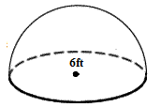

Lesson 13-4: Congruent and Similar Solids

Similar solids are solids that have exactly the same shape but not necessarily the same size.
- If the corresponding sides are proportional, then the solid is similar!

Congruent solids are solids with exactly the same shape and same size.
- If the corresponding sides are congruent, then the solid is congruent!
Ex1) Determine whether each pair of solids is similar, congruent, or neither.
- 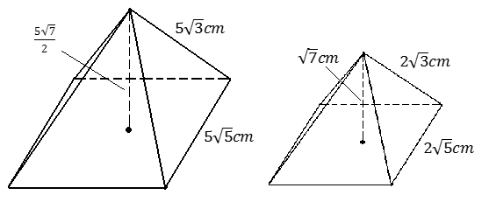

- 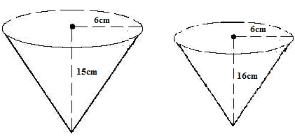

THEOREM:
If two solids are similar with a scale factor of $\frac{a}{b}$
Their surface areas have a ratio of $\frac{a^{2}}{b^{2}}$
Their volumes have a ratio of $\frac{a^{3}}{b^{3}}$

Ex2) A softball has a diameter of 3.8 inches, while a baseball has a diameter of 2.9 inches.
- Find the scale factor of the softball and baseball.

- Find the ratio of the surface areas of the softball and baseball.

- Find the ratio of the volumes of the softball and baseball.

- The volume of the softball is about 28.7 cubic inches. Find the volume of the baseball.

