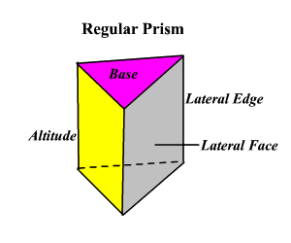
Chapter 12.2: Surface Area of Prisms
Bases:
Lateral Face:
Lateral Edges:
Altitude:

Surface Area: Sum of the areas of all the sides (faces) of a 3-D figure.
Lateral Surface Area: Sum of the areas of only the lateral faces of a 3-D figure.

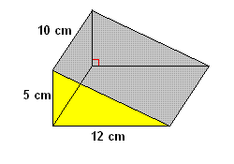
Example: Find the Lateral and Total Surface Area:

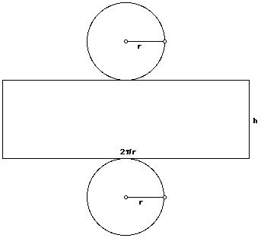
Lesson 12.3 and 12.5: Surface Area of a Cone and a Cylinder
Lateral Surface Area of a Cylinder:

Total Surface Area of a Cylinder:

Example: Find the Lateral and Total Surface Area
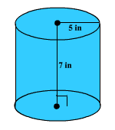
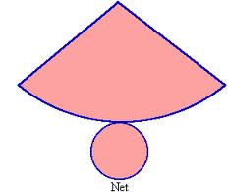
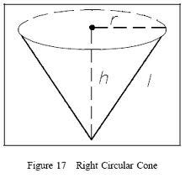
Surface Area of a Cone:
Lateral Area =
SA of Cone =

Example: Find surface area if r = 6in and h = 7in
Lesson 12.4: Surface Area of a Pyramid
Example 1)
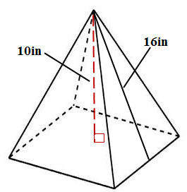
Example 2)

Example 3)

