Chapter 12/13 Practice Test
- Find the lateral area and surface area of the solid.
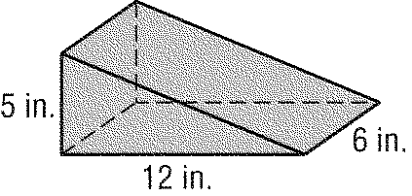

- Find the lateral area of a right cylinder with a diameter of 8.6 yards and a height of 19.4 yards. Round to the nearest tenth.

- The surface area of a cylinder is 180π square inches and the height is 9 inches. Find the radius

- The volume of a sphere is 320 cubic meters. Find the diameter of the sphere.

- Find the surface area of a right circular cone with a radius of 4 feet and a height of 3 feet. Round to the nearest tenth.

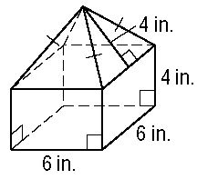
- Find the surface area of the solid.

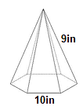
- Find the surface area and volume of the pyramid.

- Find the volume of the pyramid.

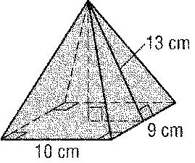

- Find the volume of the cylinder.
Round to the nearest tenth.
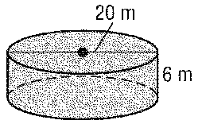

- The volume of a pyramid is 120 cubic inches and the area of the base is 50 square inches. Find the height of the pyramid.

- A sphere has a diameter of 7.36 inches long. Find the volume of the sphere. Round to the nearest tenth.

- Find the volume of the cone. Round to the nearest tenth.

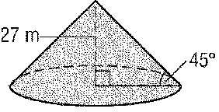

- Find the volume of the solid. Round to the nearest tenth
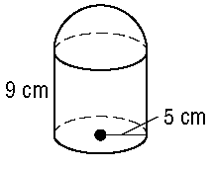

- Determine whether these two cylinders are congruent, similar, or neither.
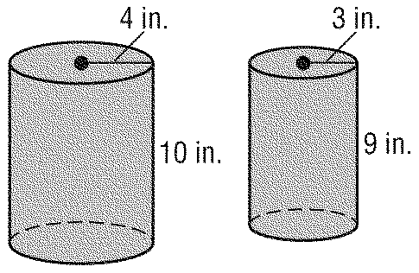

- The ratio of the volumes of two similar solids is 8:27.
  - Find the ratio of their surface areas.

  - The surface are of the larger solid is 340cm². Find the surface area of the smaller solid.

- Find the volume of the prism.
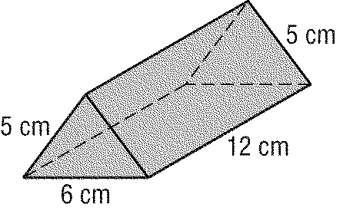

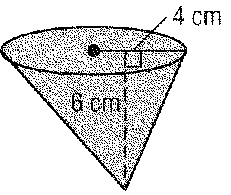
- Find the volume of the oblique cone. Round to the nearest tenth.

- Sam is filling a rectangular pan with liquid from a cylindrical can. The can is three-fourths full of water. Determine whether all of the water will fit in the pan. Explain.

