1. Find the area of quadrilateral *DEFG*.

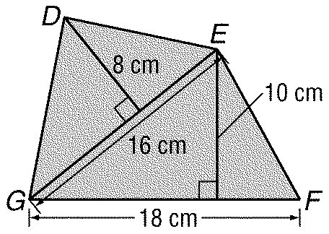

1. 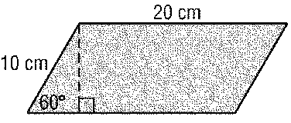Find the perimeter and area of each parallelogram. Round to the nearest tenth if necessary.
2. 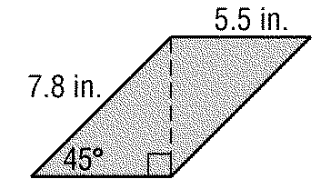
3. Find the area of trapezoid *ABCD* with vertices *A*(1, 2), *B*(5, 2), *C*(4, 4), and *D*(1, 4).
4. 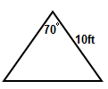Find the area of the triangle.
5. Find the area of the figures below. Round to the nearest tenth if necessary.

a.



b.

1. 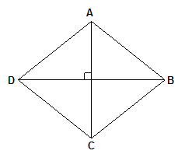The area of the figure is 672and DB is 42 in. Find AC.
2. 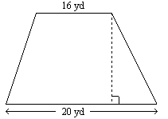The area of the figure is 180 yd2. Find the height.

1. Find the area of a circle with a circumference of 20.
2. Find the area of the figures below.
3. 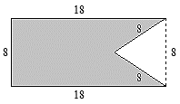

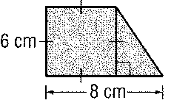

1. sdfg

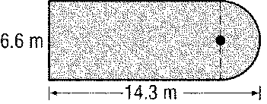

**Find the area of each polygon. Round to the nearest tenth if necessary.**

1. A regular hexagon with side length of 15 centimeters
2. A regular octagon with a perimeter of 96 centimeters
3. 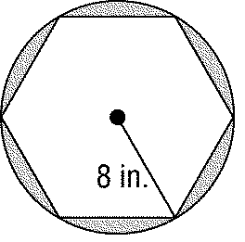Find the area of the shaded region to the nearest tenth. Assume that the hexagon is regular.