Chapter 10 Practice Test
Skills Practice Workbook

(10-1) #1-9, 10, 12, 14
(10-2) #1-14
(10-3) # 1-20
(10-4) #1-7, 13
(10-5) #1-3, 5, 7
(10-8) #1, 3, 9, 10, 12

Additional Practice: Central and Inscribed Angles
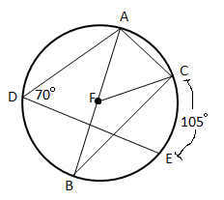
Find the missing angle measures and arc measures.
mAE= ______ m$∠AFC$= ______
mAC= ______ m$∠B$= ______
mBE= ______ m$∠ACB$= ______
mADE= ______ m$∠CFB$= ______

Additional Practice for 10-8
- .
- Find the center and radius of the circle: x² + 6y + 9 = 10x– y²
- Find the equation of a circle whose diameter has endpoints (-3,2) and (5,-6)

Chapter 10 Practice Test
Skills Practice Workbook

(10-1) #1-9, 10, 12, 14
(10-2) #1-14
(10-3) # 1-20
(10-4) #1-7, 13
(10-5) #1-3, 5, 7
(10-8) #1, 3, 9, 10, 12

Additional Practice: Central and Inscribed Angles
Find the missing angle measures and arc measures.
mAE= ______ m$∠AFC$= ______
mAC= ______ m$∠B$= ______
mBE= ______ m$∠ACB$= ______
mADE= ______ m$∠CFB$= ______

Additional Practice for 10-8
- .
- Find the center and radius of the circle: x² + 6y + 9 = 10x– y²
- Find the equation of a circle whose diameter has endpoints (-3,2) and (5,-6)

