**Chapter 7 Practice Test**

1. Find the triangle similar to *ABC* below

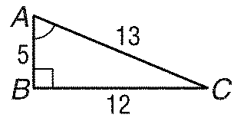

a. 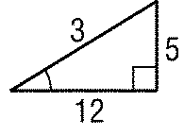 b. 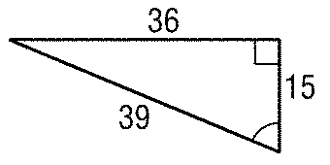 c. 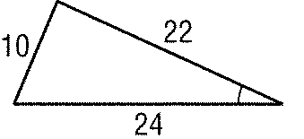 d. 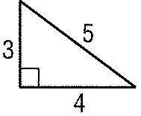

1. If *PQR*  *STU*, find *x*.

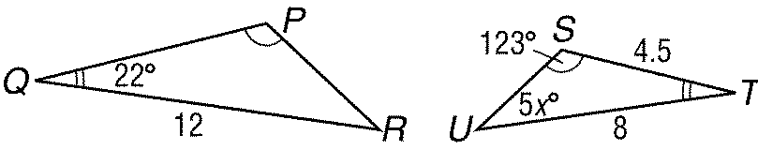

1. If *ABCD*  *EFGH*, find *x*.

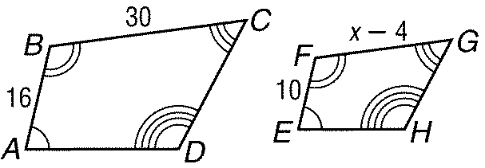

1. *ABC* ~ *LMN, AB*  18, *BC*  12, *LN*  9, and *LM*  6. What is the scale factor of *ABC* to *LMN*?

**Refer to the figure below.**

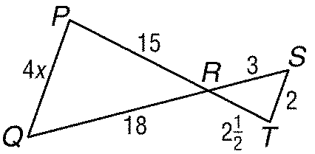

1. Identify the true statement.

a. *PQR*  *RST* b. *PQR*  *STR* c. *PQR*  *TSR* d. *PQR*  *TRS*

1. Find *x*.
2. When a 9-foot tall garden shed cast a 5-foot, 3-inch shadow, a house cast a 28-foot shadow. Find the height of the house.

*Determine whether each pair of triangles is similar. Justify your answer.*

1. 

a. No; sides are not proportional.

b. yes;  by SSS Similarity

c. yes;  by SSS Similarity

d. yes;  by SSS Similarity

1. What type of dilation occurs with a scale factor of 1?

1. Find the scale factor if  is the image of *XYZ* under a dilation with center *C*.

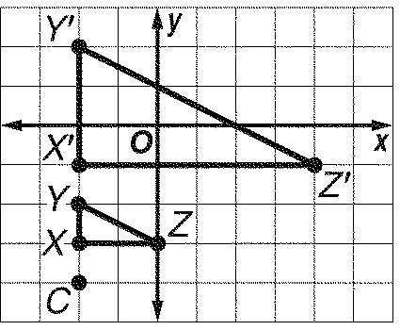

a. 6 b. 3

c. 2 d. 

1. Find *x*.

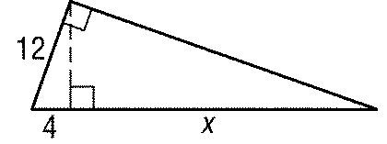

1. *ABC*  *LMN*, and *AD* and *LP* are altitudes. Find *AD*.

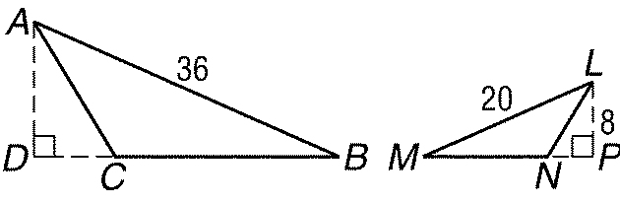

1. a) A’B’ = 16, r = $\frac{4}{3}$, AB=____

b) AB = 8, r = -2, A’B’ = ____

c) A’B’ = 9, r = 3, AB = ____

d) AB = 10, r = $\frac{2}{5}$, A’B’ = ____

1. Find *GP*.

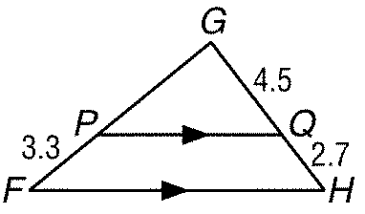

1. Determine whether *ABC*  *PQR*. Justify your answer.

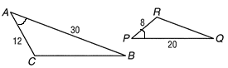

1. *ABC*  *PQR, AB*  18, *BC*  20, *AC*  22, and *QR*  25. Find the perimeter of *PQR*.

**Use the figure below.**

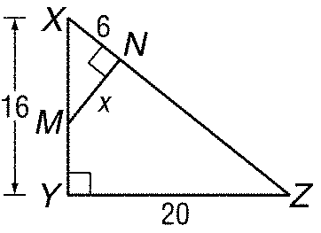

1. Identify the similar triangles.
2. Find x
3. State the scale factor
4. If *FGH*  *LMN* and *AF* and *BL* are medians, find *BL*.

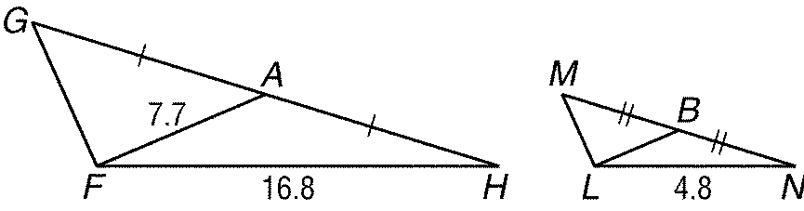

1. If quadrilateral *DEFG* quadrilateral *WXYZ*, find *m**Y*.

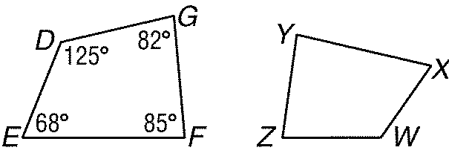

1. Find *x* so that *PQ*  *FH*.

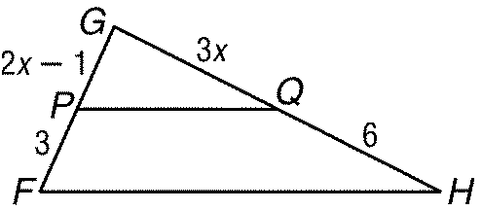

1. Find *y*.

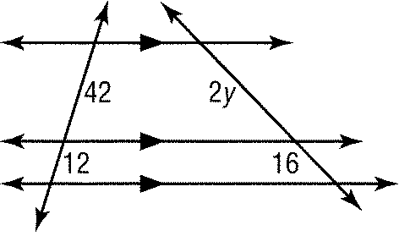

1. Identify the similar triangles, find x, find the measures of the indicated side, and then state the scale factor.



1. ΔPQR ~ _____
2. x = ____
3. RP = ____
4. RT = ____
5. Scale factor: ____
6. Find x

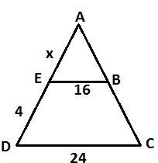

1. Solve
$\frac{x+1}{5}=\frac{2x+3}{-2}$

$\frac{x+5}{7}=\frac{-1}{x-3}$

2. Find *EG*.

