AP Statistics Ch11 Practice Name:____________________

- In statistics, what is meant by the P-value?

- Explain the difference between a one-sided alternative hypothesis and a two-sided alternative hypothesis.

- What is meant by a significance level?

- What two circumstances guide in choosing a level of significance?

- Why is it important to always plot your data?

- What is a Type I Error?

- What is a Type II Error ?

- What is the relationship between the significance level α and the probability of Type I Error?

- What is meant by the power of a significance test?

- Fill out the following chart with the following: Incorrect Decision, Correct Decision, Type I Error, Type II Error, Power, α, 1 – α, β, 1 – β
 | H0 is true | Ha is true
Reject H0
Fail to reject H0

- State four ways to increase the power of a significance test:

State the null and alternative hypotheses
- A manufacturer claims that a new brand of air-conditioning unit uses only 6.5 kilowatts of electricity per day with a standard deviation of 1.4. A consumer agency believes the true figure is higher and runs a test on a sample of size 50. The sample mean is 7.0 kilowatts.

- A local chamber of commerce claims that the mean family income level in a city is $12,250. An economist believes that this is incorrect. He runs a hypothesis test, using a sample of 135 families, and finds a mean of $11,500 with a standard deviation of $3,180.

- For each α and observed significance level (p-value) pair, indicate whether the null hypothesis would be rejected.
- α = . 05, p = .10
- α = .10, p = .05
- α = .01 , p = .001
- α = .025 , p = .05
- α = .10, p = .45

- The one-sample Z statistic for testing
H₀: μ = 0
H_{a}: μ > 0
has the value Z = 1.98.
- Is the value Z = 1.98 significant at the 5% level? Why?
- Is the value Z = 1.98 significant at the 1% level? Why?

- The one-sample Z statistic for the two-sided test of
H₀: μ = 0
H_{a}: μ ≠ 0
has the value Z = -2.58.
- Is the value Z = -2.58 significant at the 5% level?
- Is the value Z = -2.58 significant at the 1% level?

- City Emergency response times to serious accidents are reported at 6.7 minutes. Local officials are concerned that the actual response times are larger than the report indicates.
H₀: μ = 6.7 minutes
H_{a}: μ > 6.7 minutes
Describe and give the consequences of a Type I error and a Type II error. Decide whether you would choose an alpha level of 0.01 or 0.1 and explain why.

- State the probability of a Type I error and the probability of a Type II error. 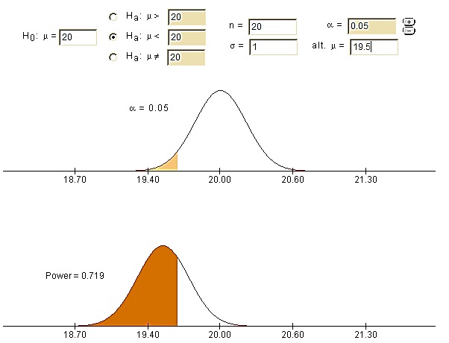

Perform a FULL TEST for the following

- A professional pickologist believes that the average times a day a person picks their nose is 3, with a standard deviation of 1 nose pick. A researcher tests this claim to see if the true average is greater than 3, using an SRS of 500 people. She finds the sample mean to be 3.1 nose picks. Is this sufficient evidence at the 5% level to reject the professional pickologist’s claim?

- A pharmaceutical manufacturer does a chemical analysis to check the potency of toe fungus cream. The standard release potency for the active ingredient, fungicitis-eliminatus, is 20, with a known population deviation of 3. A sample of 20 lots gives the following potency data:
22 20 18 14 13 26 28 18 25 21
18 16 15 23 28 26 27 21 20 25

Is there significant evidence at the 5% level that the mean potency is not equal to the standard release potency?

