AP STATISTICS: Worksheet Chapter 8 Name ________________________

 THE TWELVE DAYS OF STATISTICS 



On the first day of Statistics, my true love gave to me: A Partridge in a Pear Tree.
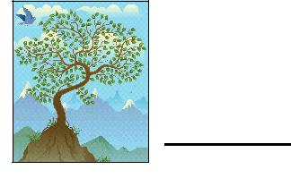
If the probability of getting a partridge is 0.58 and the probability of getting a pear tree is 0.76, and these are independent events, find the probability of getting a partridge and a pear tree.


On the second day of Statistics, my true love gave to me: Two Turtle Doves.

If the probability of a fem ale turtle dove is 0.53, find the probability of at least

one female turtle dove in the pair.



On the third day of Statistics, my true love gave to me: Three French Hens.
If the probability of a hen truly having French citizenship is 0.81, find the

probability of exactly two French hens out of the three.


On the fourth day of Statistics, my true love gave to me: Four Calling Birds.

If there is an infinite number of calling birds and the probability of a bird actually calling is 0.63, find the probability of finding the first calling bird on the third attempt.


On the fifth day of Statistics, my true love gave to me: Five Golden Rings.
If the probability of getting a real golden ring is 0.72, find the probability of

getting three or fewer golden rings in the five.



On the sixth day of Statistics, my true love gave to me: Six Geese A-laying.
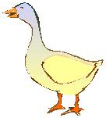
If the probability of an authentic laying goose is 0.83 and there is an unlimited number of geese, find the probability of getting a laying goose on or before the fourth trial.




On the seventh day of Statistics, my true love gave to me: Seven Swans A-swimming.
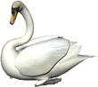
If the probability of a swan drowning is 0.23, find the probability of exactly 4 out of

the 7 swans drowning.



On the eighth day of Statistics, my true love gave to me: Eight Maids A-milking.
If the probability of getting a sour maid a-milking is 0.38, find the expected number of sour maids a-milking in the group of 8.



On the ninth day of Statistics, my true love gave to me: Nine Ladies Dancing.
If the probability of a dancing lady accepting an invitation to dance is 0.18, find the expected number of ladies you would have to ask before one accepts.



On the tenth day of Statistics, my true love gave to me: Ten Lords A-leaping.
If the probability of a lam e leaping lord is 0.24 and there is an unlimited number of leaping lords, find the probability of getting your first lam e leaping lord after the sixth attempt.



On the eleventh day of Statistics, my true love gave to me: Eleven Pipers Piping.
If the probability of frozen pipes is 0.63, find the probability of 8 or more frozen

pipes out of the eleven.



On the twelfth day of Statistics, my true love gave to me: Twelve Drummers Drumming.
If the probability of a dribbling drummer is 0.48, find the standard deviation of the dribbling drummers drumming for twelve drummers drumming.



If you round all answers to three significant digits,

the sum of the twelve answers should be 14.047

