**Chapter 9.1: Sampling Distributions**

**Parameter ($μ, ρ)$**: A number that described the population. In practice, the parameter is unknown.

**Statistic ($\overline{x}, \hat{p})$:** A number that can be computed from the sample data. Used to estimate the unknown parameter.

**Sampling Variability:** If we were to take multiple samples of size *n* from a population, our statistic would vary from sample to sample.

**Sampling Distribution of a Statistics:**

**Behavior of Sampling Distributions**: (The effect of sample size)







**1) Center (Mean)**

**2) Spread (Variability)**

**3) Shape**



**Unbiased Statistics/Unbiased Estimator:**  A statistics used to estimate a parameter is **unbiased** if the mean its sampling distribution is equal to the true value of the parameter being estimated.

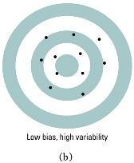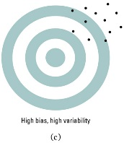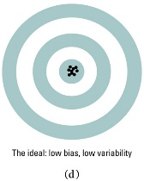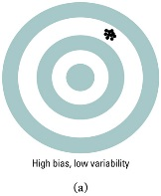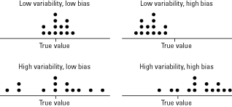**Note on Variability:** The variability of a sampling distribution depends on sample size, not population size. As long as the population is much larger than the sample (at least 10 time “n), the population size has little impact on the spread of the sampling distribution.

**Chapter 9.2: Sample Proportions**

The following properties generally describe a sampling distribution of **proportions**:

1. **If the sample size is large enough** (or if we are told that the **population is normally distributed**) The overall shape of the distribution is symmetric and approximately normal. The larger the sample size the closer the shape is to a normal distribution.
   1. A rule of thumb used to determine if a normal curve can be used to approximate the sampling distribution of population proportions if:

1. The mean (center) of the distribution is equal to the _______________________, ____.
2. The variability (spread) of the sampling distribution depends on the __________. The larger the sample-size the __________ the variability of the sampling distribution.
3. **If the population is at least ten times larger than the sample size (**__________). The standard deviation of the sampling distribution is:

**Example:** An SRS of 1500 high school seniors in CA was asked whether they applied to college early. Let’s assume that there are 100,000 high school seniors in the state of California, and that in fact 35% of them apply to college early. What is the probability that your sample of 1500 seniors will give a result within 2 percentage points of the true value of 35%?

Step 1: Find the mean of the sampling distribution.

Step 2: Find the standard deviation of the sampling distribution. (VERIFY INDEPENDENCE FIRST!)

Step 3: Perform a Normal Calculation. (VERIFY THAT THE DISTRIBUTION IS (APPX) NORMAL FIRST!!!)

Example 2: Survey undercoverage—One way of checking the undercoverage, nonresponse, and other sources of error in a sample survey is to compare the sample with known facts about the population. About 11% of American adults identify as African American. The proportion $\hat{p}$ of African American adults in an SRS of 1500 adults should therefore be close to 0.11. It is unlikely to be exactly 0.11 because of sampling variability. If a national sample contains only 9.2% African American adults, should we suspect the sampling procedure is somehow under representing African American adults?

Step 1: Find the mean of the sampling distribution.

Step 2: Find the standard deviation of the sampling distribution. (VERIFY INDEPENDENCE FIRST!)

Step 3: Perform a Normal Calculation. (VERIFY THAT THE DISTRIBUTION IS (APPX) NORMAL FIRST!!!)