Geometry Day #3:
Can you re-draw draw and label the 2D triangles in the cuboid below?
Calculate the sides and angles of each triangle.
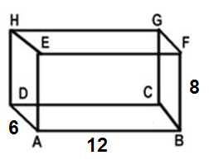
Triangle ADE Triangle ACB Triangle ACG

Can you re-draw and label the 2D triangles in the pyramid below?
Calculate the sides and angles of each triangle.

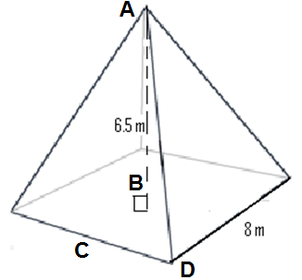

Triangle ABC Triangle ABD Triangle ACD

On each figure, mark the angle described.
In the space below, draw and label the right triangle(s) it creates.
The angle that face ADHE makes with the line EG.  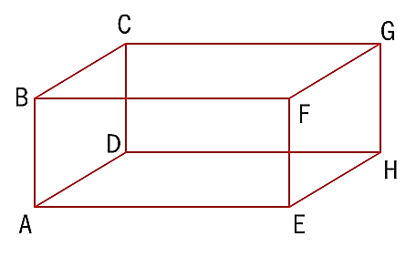 | The angle that face ADHE makes with the line EC. | The angle that face EFGH makes with the line CE.
The angle between lines CE and CF. | The angle between lines CE and EA. | The angle between planes ADGF and ADHE.
The angle between the base of the pyramid and the edge EC.  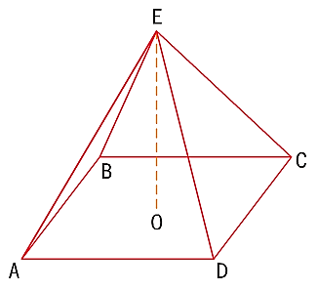 | The angle between edges EC and AE. | The angle between ME and the base, where M is the midpoint of CD.
The angle between AT  and the base.  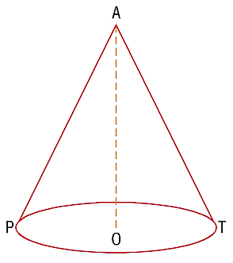 | The angle between AT  and the diameter. | The angle between AT  and AP.

1. The diagram shows a cuboid ABCDEFGH, where AD = 7cm, DC = 4cm, and CG = 3cm.
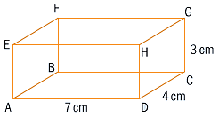

a) Find the length of
i) AH

ii) AC

iii) DG

iv) AG

b) Find the distance between
i) the midpoint of CG and A.

ii) the midpoint of AD and the midpoint of CG.

Geometry Day #4: Surface Area and Volume of 3D Shapes
Shape | Volume Formula | Surface Area Parts
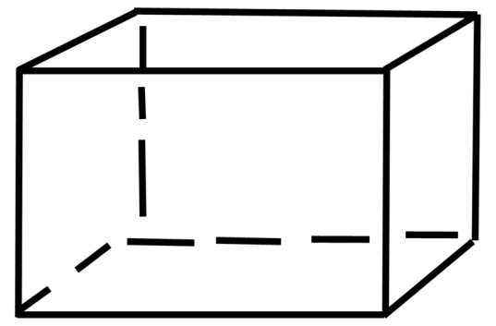

Cuboid

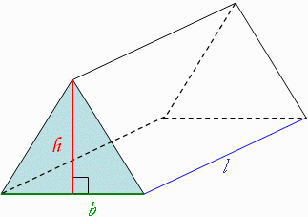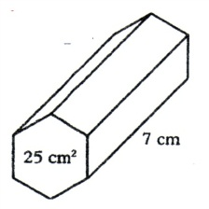

Prism

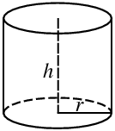

Cylinder

Shape | Volume Formula | Surface Area Parts
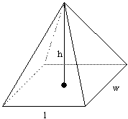

Pyramid

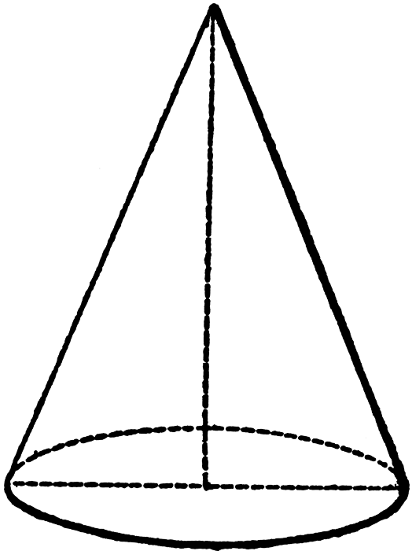

Cone

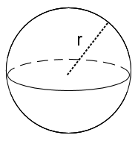

Sphere

Geometry Day #4: Surface Area and Volume of 3D Shapes

1. The radius of a cone is 12 cm and the height is 16 cm. Find the volume and surface area of the cone.

2. Find the volume and surface area of the following prism.

