13.1 Comparing Two Means Practice
SHOW ALL STEPS FOR FULL CREDIT (#3-5 are “full processes”)
- For each, say whether a paired t-test or two-sample t-test should be used.
a. The weight of 14 patients before and after open-heart surgery.
b. The smoking rates of 14 men measured before and after a stroke.
c. The number of cigarettes smoked per day by 14 men who have had strokes compared with the number smoked by 14 men who have not had strokes.
d. The lead concentration upstream from five power plants compared with the levels downstream from the same plants.
e. The basal metabolic rate (BMR) of seven chimpanzees compared with the BMR of seven gorillas.
f. The photosynthesis rate of leaves in the crown of 10 Sitka spruce trees compared with the photosynthesis rate of leaves near the bottom of the same trees.
g. The photosynthetic rates of 10 randomly chosen Douglas-fir trees compared with 10 randomly chosen western red cedar trees.
h. The photosynthetic rate measured on 10 randomly chosen Sitka spruce trees compared with the rate measured on the Western red cedar growing next to each of the Sitka spruce trees.
2) Improving Sleep It is thought that listening to the sound of the surf will help people get to sleep faster. An experiment was done using 20 people. For 10 individuals, the sound of surf was piped into their bedroom. For the other 10, no sound was used. The experiment was run for a period of time and the average time it took for them to fall asleep was monitored and averaged. Following is the data for each group.
With Surf | 10.2 | 12.5 | 13.2 | 23.1 | 7.5 | 8.9 | 12.2 | 13.4 | 18.4 | 17.5
Without Surf | 11.4 | 13.5 | 14.5 | 22.3 | 10 | 12.3 | 15 | 14.4 | 19.5 | 19.7

- Check the conditions for performing a two sample t-test for means.
- What is the standard error of the differences of the two independent samples?

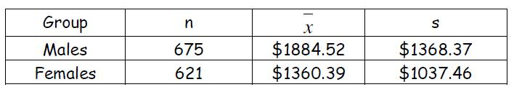
3) Paying for College College financial aid offices expect students to use summer earnings to help pay for college. But how large are these earnings ? One college studied this question by asking a random sample of students how much they earned. Omitting students who were not employed, there were 1296 responses. Here are the data in summary form:

Construct a 90% confidence interval for the difference between the mean summer earnings of male and female students.

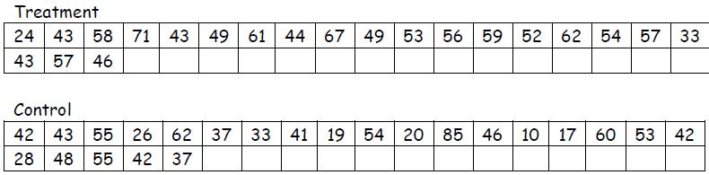
4) Teaching Reading An educator believes that new reading activities in the classroom will help elementary school pupils improve their reading ability. She arranges for a third-grade class of 21 students to follow these activities for an 8 week period. A control classroom of 23 third graders follows the same curriculum without the activities. At the end of the 8 weeks, all students are given the Degree of Reading Power (DRP) test, which measures the aspects of reading ability that the treatment is designed to improve. Here are the data.

Is there good evidence that the new activities improve the mean DRP score?

5) Nicotine and Guinea Pigs Many studies have shown that smoking during pregnancy affects the baby’s health. Researcher’s investigated the behavior of guinea pig offspring whose mothers had been randomly assigned to receive either a normal saline or nicotine saline injection throughout pregnancy. Each group consisted of 15 randomly chosen male and female guinea pigs. At 85 days of age, 10 subjects from each group were randomly chosen to run a maze and choose a black door rather than a white door at the end of the maze. The number of trials it took each guinea pig to complete the task successfully with no more than one mistake in two consecutive days was recorded. Here are the summary statistics on number of trials to successful completion for the nicotine group and the control group:
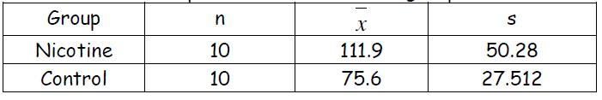
Note: Both normal probability plots of the data were linear.

Is there a significant difference in the mean number of trials recorded between the treatment group and the control group?

13.1 Comparing Two Means Practice
SHOW ALL STEPS FOR FULL CREDIT (#3-5 are “full processes”)
- For each, say whether a paired t-test or two-sample t-test should be used.
a. The weight of 14 patients before and after open-heart surgery.
b. The smoking rates of 14 men measured before and after a stroke.
c. The number of cigarettes smoked per day by 14 men who have had strokes compared with the number smoked by 14 men who have not had strokes.
d. The lead concentration upstream from five power plants compared with the levels downstream from the same plants.
e. The basal metabolic rate (BMR) of seven chimpanzees compared with the BMR of seven gorillas.
f. The photosynthesis rate of leaves in the crown of 10 Sitka spruce trees compared with the photosynthesis rate of leaves near the bottom of the same trees.
g. The photosynthetic rates of 10 randomly chosen Douglas-fir trees compared with 10 randomly chosen western red cedar trees.
h. The photosynthetic rate measured on 10 randomly chosen Sitka spruce trees compared with the rate measured on the Western red cedar growing next to each of the Sitka spruce trees.
2) Improving Sleep It is thought that listening to the sound of the surf will help people get to sleep faster. An experiment was done using 20 people. For 10 individuals, the sound of surf was piped into their bedroom. For the other 10, no sound was used. The experiment was run for a period of time and the average time it took for them to fall asleep was monitored and averaged. Following is the data for each group.
With Surf | 10.2 | 12.5 | 13.2 | 23.1 | 7.5 | 8.9 | 12.2 | 13.4 | 18.4 | 17.5
Without Surf | 11.4 | 13.5 | 14.5 | 22.3 | 10 | 12.3 | 15 | 14.4 | 19.5 | 19.7

- Check the conditions for performing a two sample t-test for means.
- What is the standard error of the differences of the two independent samples?

3) Paying for College College financial aid offices expect students to use summer earnings to help pay for college. But how large are these earnings ? One college studied this question by asking a random sample of students how much they earned. Omitting students who were not employed, there were 1296 responses. Here are the data in summary form:

Construct a 90% confidence interval for the difference between the mean summer earnings of male and female students.

4) Teaching Reading An educator believes that new reading activities in the classroom will help elementary school pupils improve their reading ability. She arranges for a third-grade class of 21 students to follow these activities for an 8 week period. A control classroom of 23 third graders follows the same curriculum without the activities. At the end of the 8 weeks, all students are given the Degree of Reading Power (DRP) test, which measures the aspects of reading ability that the treatment is designed to improve. Here are the data.

Is there good evidence that the new activities improve the mean DRP score?

5) Nicotine and Guinea Pigs Many studies have shown that smoking during pregnancy affects the baby’s health. Researcher’s investigated the behavior of guinea pig offspring whose mothers had been randomly assigned to receive either a normal saline or nicotine saline injection throughout pregnancy. Each group consisted of 15 randomly chosen male and female guinea pigs. At 85 days of age, 10 subjects from each group were randomly chosen to run a maze and choose a black door rather than a white door at the end of the maze. The number of trials it took each guinea pig to complete the task successfully with no more than one mistake in two consecutive days was recorded. Here are the summary statistics on number of trials to successful completion for the nicotine group and the control group:
Note: Both normal probability plots of the data were linear.

Is there a significant difference in the mean number of trials recorded between the treatment group and the control group?

