Lesson 12.1
The quick brown fox jumped over the lazy dog
Mrs. Skaff typed this sentence into her iphone (no typos) in 10 seconds. She believes that her students are faster than her! Is she correct?
Data:

State:
State Hypotheses:

State Alpha:

Plan:
Name Inference Procedure:

Check assumptions/Conditions:

Calculate:
Find test statistic:

Degrees of freedom:

Draw curve and shade Find the p-value from the
t-table (or calculator):

Interpretation (Be sure to state in terms of parameter)

Paired t-test
Let’s compare texting speeds for dominant vs. non-dominant hand!
The quick brown fox jumped over the lazy dog

State:

Plan:
Name Inference Procedure:
State Alpha:

State Hypotheses:

Check assumptions/conditions:

Calculate:
Find test statistic:

Degrees of freedom:

Draw curve and shade Find the p-value from the
t-table (or calculator)::

Interpretation (Be sure to state in terms of parameter)

Type I and Type II Error
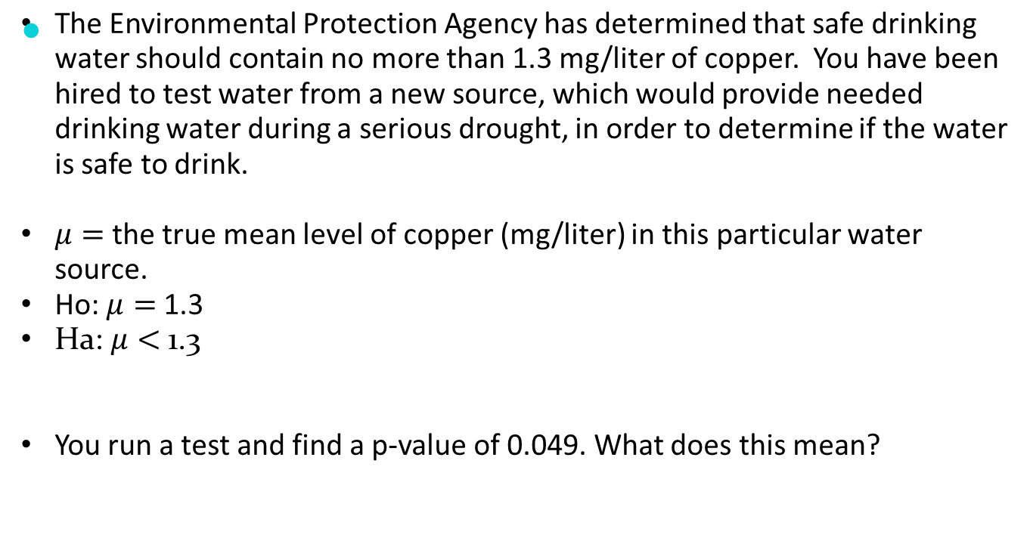We make a “Type I Error” when we incorrectly reject H₀.
We make a “Type II Error” when we incorrectly fail to reject H₀.
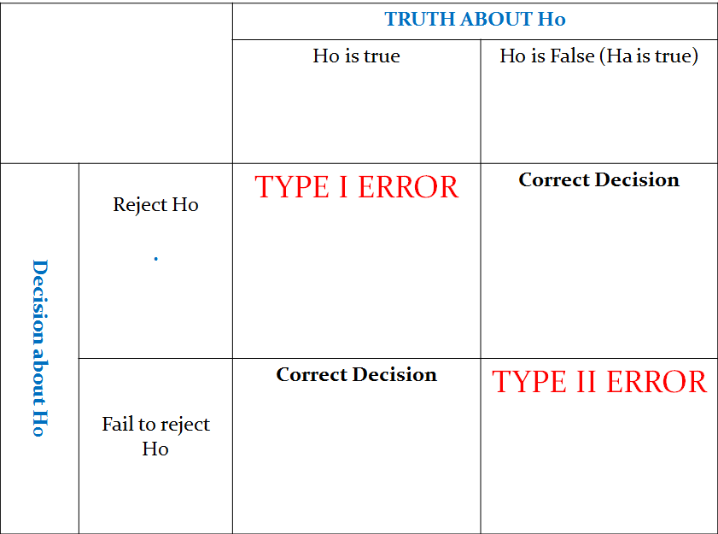
Typically, you will be asked to describe each error and state a consequence for each.
- Type I: Inform the EPA that the water is safe to drink when it is actually UNSAFE!
- Consequence:

- Type II: Inform the EPA that the water is not safe to drink even though it really WAS safe.
- Consequence:

Which error do you believe is more serious? Why?
If you had to choose and alpha level of α = 0.1, 0.05, or 0.01 which would you choose? Why?

Error Probabilities:
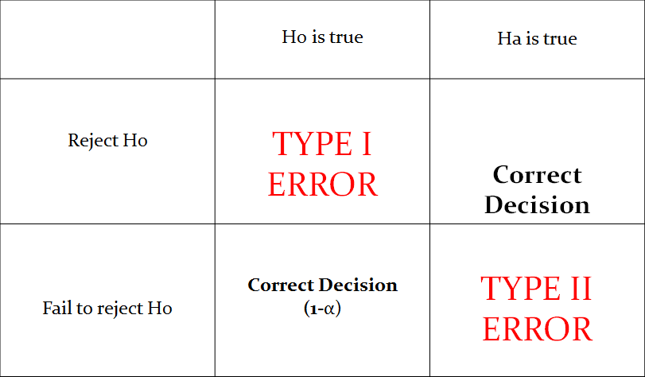
The “Power” of a test is the probability of correctly rejecting the null hypothesis
How to increase the Power of a test:

