10a Notes – Math Studies IB

Can you re-draw draw and label the 2D triangles in the cuboid below?
Calculate the sides and angles of each triangle.

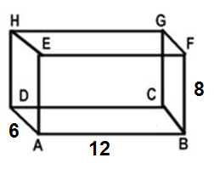
Triangle ADE Triangle ACB Triangle ACG

Can you re-draw and label the 2D triangles in the pyramid below?
Calculate the sides and angles of each triangle.

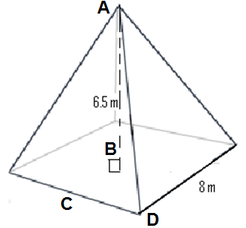

Triangle ABC Triangle ABD Triangle ACD

1. The diagram shows a cuboid ABCDEFGH, where AD = 7cm, DC = 4cm, and CG = 3cm.

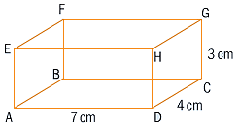

For each problem, RE-DRAW an appropriate triangle

a) Find the length of

i) AH

ii) AC

iii) DG

iv) AG

b) Find the distance between

i) the midpoint of CG and A.

ii) the midpoint of AD and the midpoint of CG.

2. In the diagram, ABCD is the rectangular base of a right pyramid with apex E. The sides of the base are 8 cm and 5 cm, and the height OE of the pyramid is 7 cm.

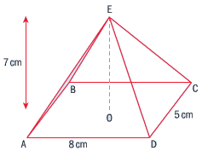

For each problem, RE-DRAW an appropriate triangle

a) Find the length of

i) AC

ii) EC

iii) EM, where M is the midpoint of CD.

b) Find the area of

i) Triangle BCD

ii) Triangle ECD

iii) Triangle EDA

On each figure, mark the angle described.
In the space below, draw and label the right triangle(s) it creates.

The angle that face ADHE makes with the line EG.  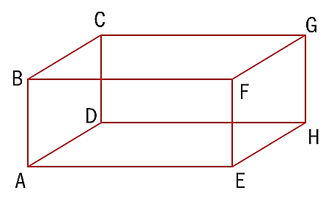 | The angle that face ADHE makes with the line EC. | The angle that face EFGH makes with the line CE.
The angle between lines CE and CF. | The angle between lines CE and EA. | The angle between planes ADGF and ADHE.

The angle between the base of the pyramid and the edge EC.  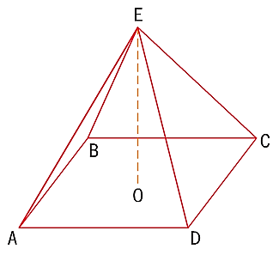 | The angle between edges EC and AE. | The angle between ME and the base, where M is the midpoint of CD.

The angle between AT  and the base.  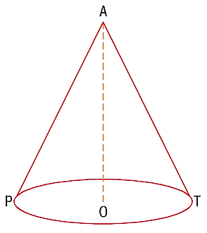 | The angle between AT  and the diameter. | The angle between AT  and AP.

